SISTEM PENDUKUNG KEPUTUSAN PENERIMA

BANTUAN BIBIT JAGUNG MENGGUNAKAN

METODE SIMPLE MULTY ATTRIBUTE

RATING TECHNIQUE (SMART)
(Studi kasus : kantor desa manawa)

Oleh
PENDRIS R. YASIN
T3117284

SKRIPSI

Untuk memenuhi salah satu syarat ujian
Guna memperoleh gelar Sarjana



PROGRAM SARJANA
TEKNIK INFORMATIKA
UNIVERSITAS ICHSAN GORONTALO
GORONTALO
2021



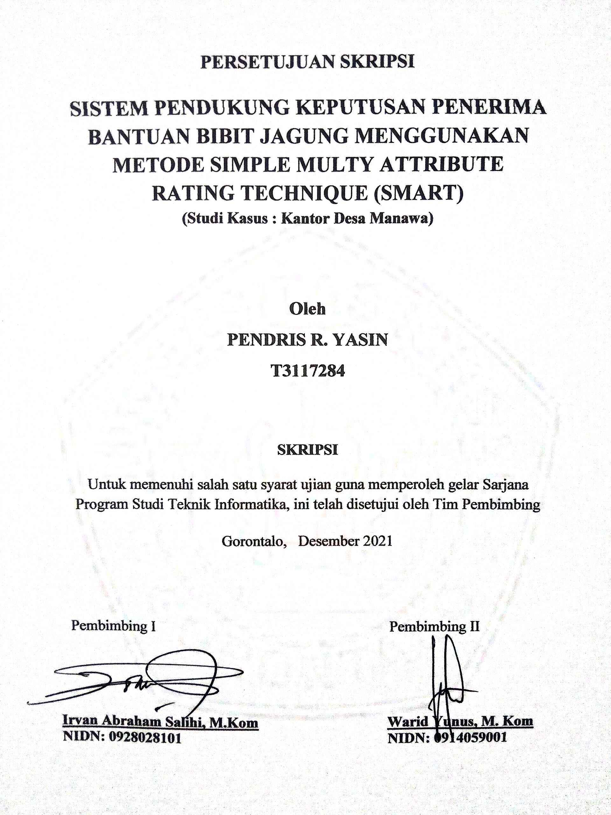

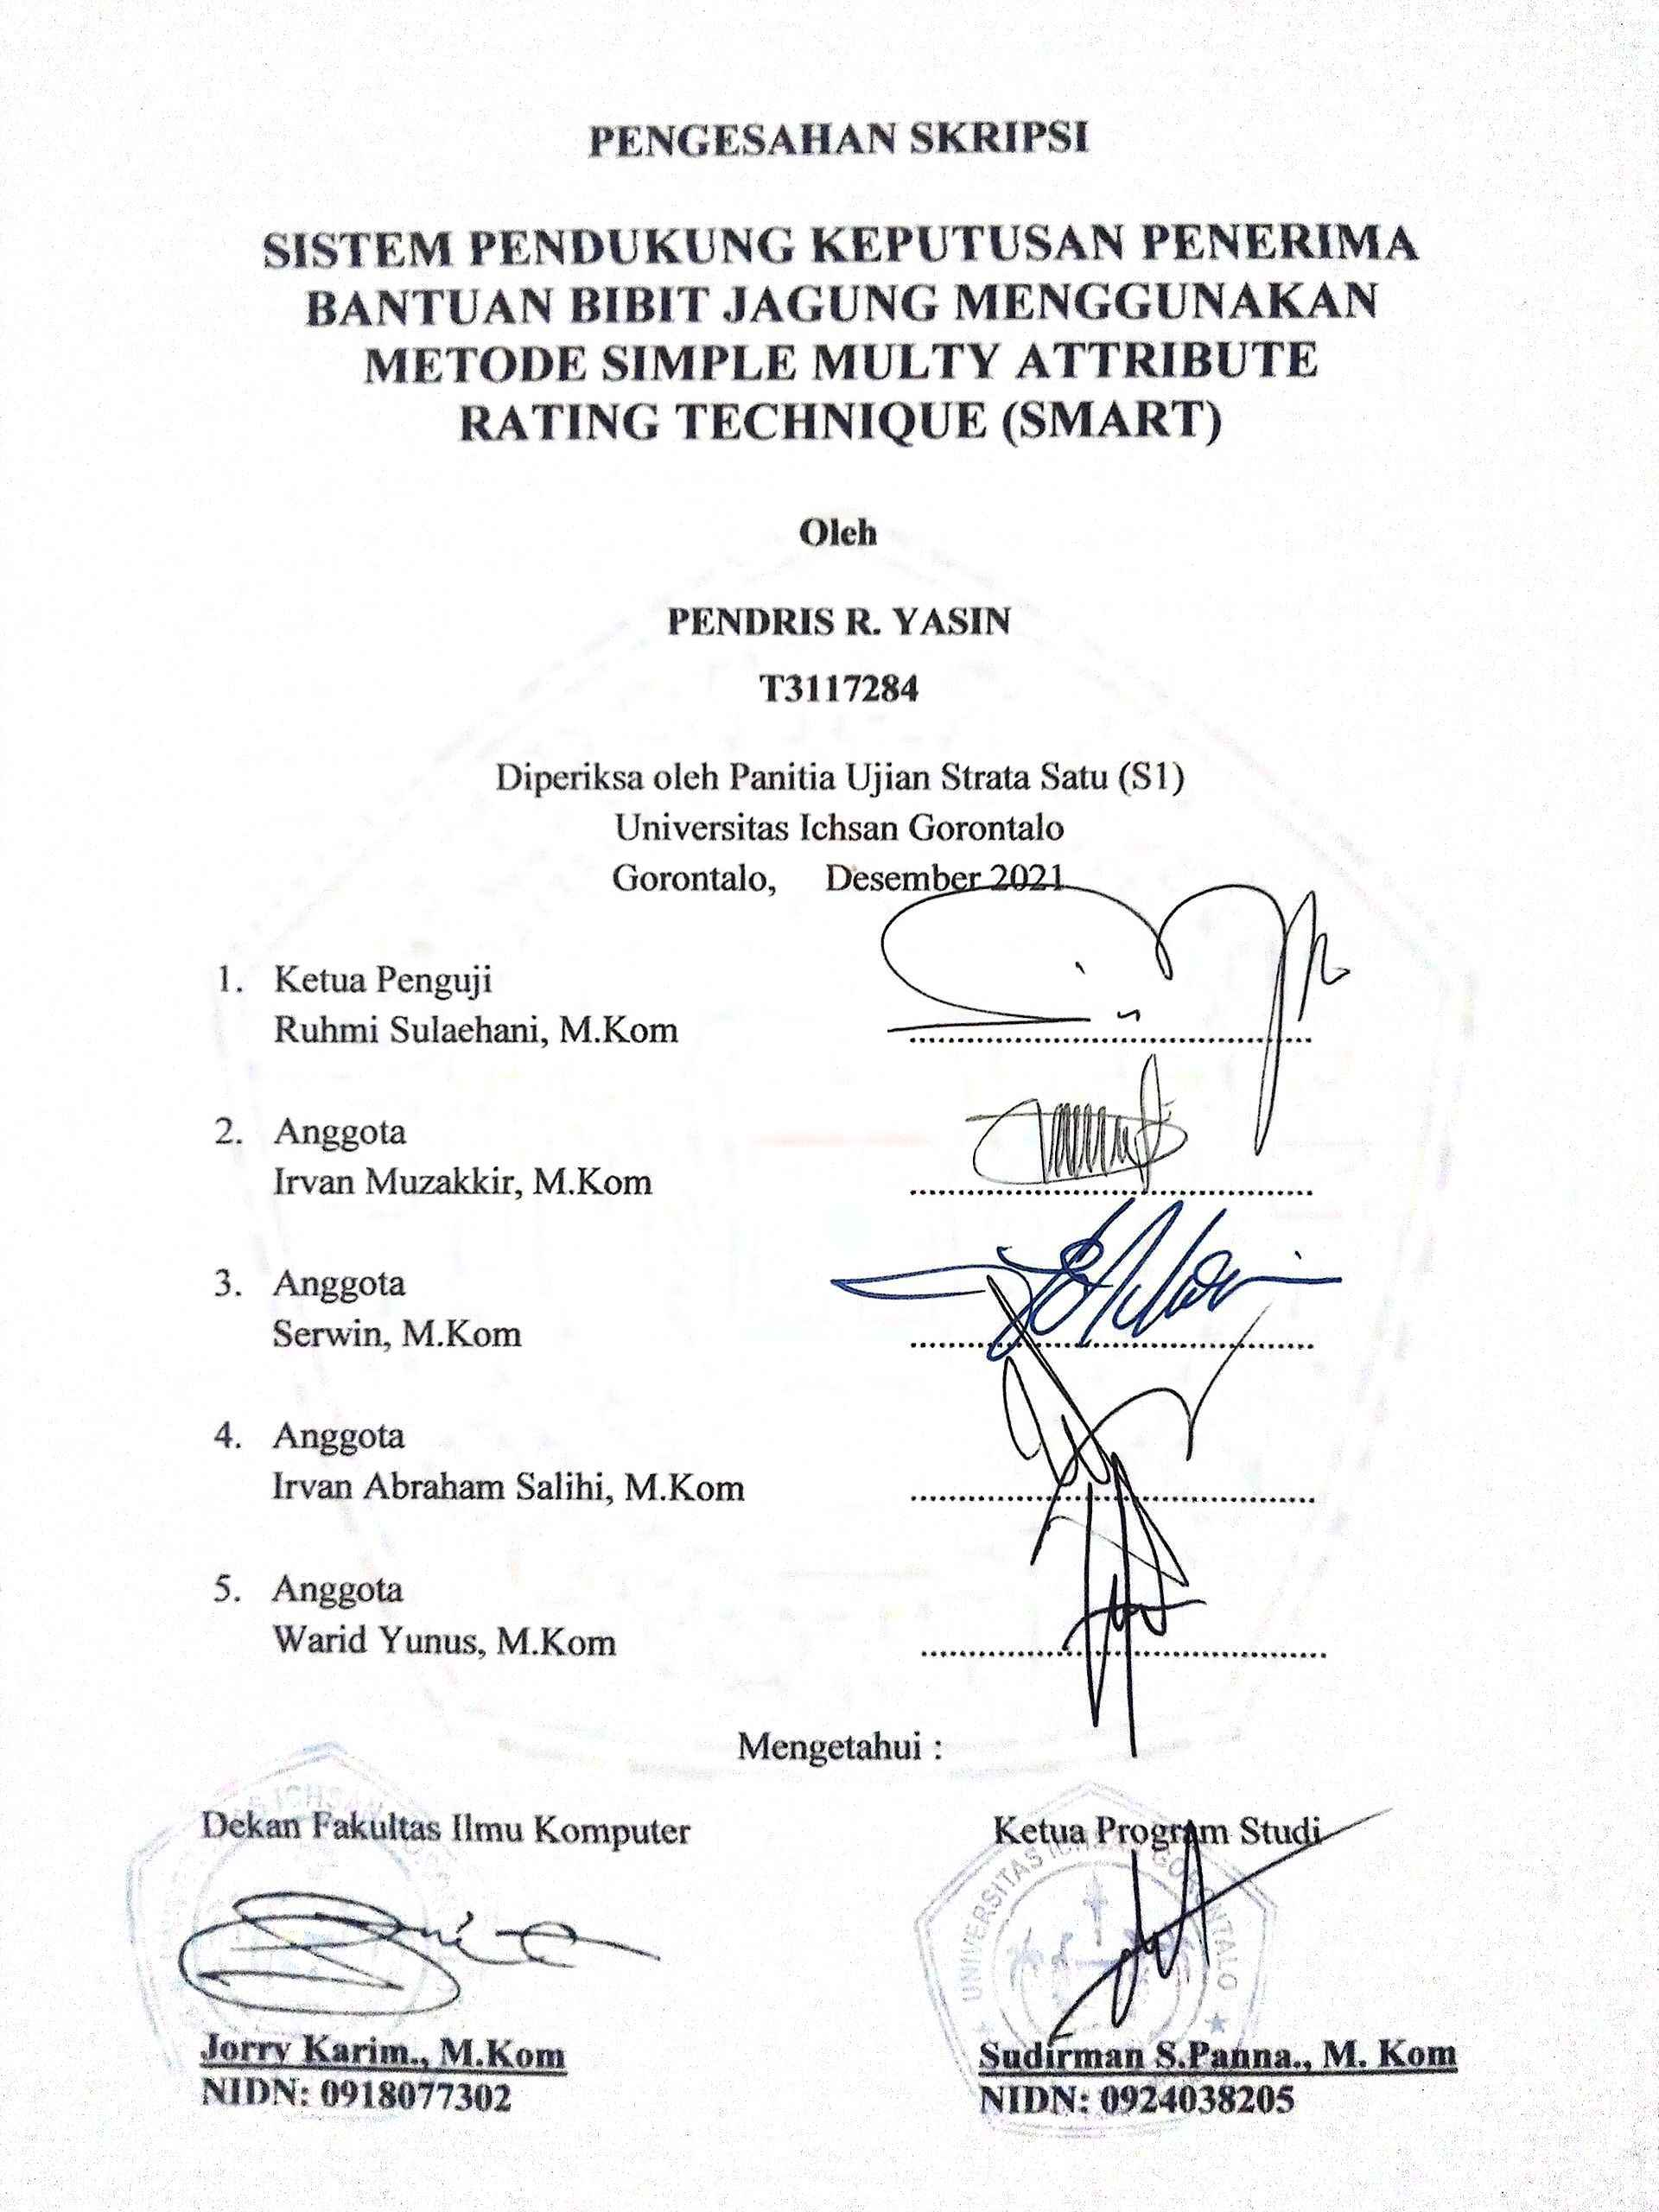



ABSTRACK

Corn seeds are seeds that are used as a source of plant propagation. The definition of seeds can be distinguished biologically and agronomically. Seedlings are agronomically defined as plant seeds needed for crop purposes and farming development. The purpose of this research is to create a decision support system that will be implemented at the Manawa Village Office, which is expected to facilitate the process of receiving corn seed assistance in the community. To overcome this problem, namely by building a decision support system for recipients of corn seed assistance using the Simple Multi Attribute Rating Technique (SMART) method with the PHP and MySQL programming languages to assist the staff of the Manawa Village Office in choosing the right target who is entitled to receive the assistance.

Keywoards : SPK, Bantuan Bibit Jagung, Simple Multi Attribute Rating Technique (SMART)

ABSTRAK

Bibit jagung merupakan bibit yang digunakan sumber perbanyakan tanaman. Batasan tentang pengertian bibit dapat dibedakan secara biologi, dan secara agronomis. Secara agronomis bibit didefinisikan sebagai bibit tanaman yang diperlukan untuk tanaman keperluan dan pengembangan usaha tani. Secara biologi bibit merupakan bibit tumbuhan yang digunakan untuk alat perkembangbiakan tanaman. Adapun tujuan dari penelitian ini yaitu untuk membuat suatu sistem pendukung keputusan yang akan diterapkan di Kantor Desa Manawa, diharapkan dapat mempermudah proses penerima bantuan bibit jagung pada masyarakat tersebut. Untuk mengatasi permasalahan tersebut yaitu dengan membangun sebuah sistem pendukung keputusan penerima bantuan bibit jagung menggunakan metode Simple Multi Attribute Rating Technique (SMART) dengan bahasa pemrograman PHP dan MySQL untuk membantu bagian staf Kantor Desa Manawa dalam memilih dengan tepat sasaran siapa yang berhak menerima bantuan tersebut.

Kata Kunci : SPK, Bantuan Bibit Jagung, Simple Multi Attribute Rating Technique (SMART)

KATA PENGANTAR

Segala Puji bagi Allah SWT karena dengan Taufiq dan Hidayah-Nya lah sehingga penulis dapat menyelesaikan penelitian ini dengan judul, “Sistem Pendukung Keputusan Penerima Bantuan Bibit Jagung Menggunakan Metode SMART”, untuk memenuhi salah satu syarat penyusunan Proposal Program Studi Teknik Informatika Fakultas Ilmu Komputer Universitas Ichsan Gorontalo.
Penulis menyadari sepenuhnya bahwa usulan penelitian ini tidak mungkin terwujud tanpa bantuan dan dorongan dari berbagai pihak, baik bantuan moril maupun material. Untuk itu dangan segala keikhlasan dan kerendahan hati, penulis mengucapkan banyak terima kasih dan penghargaan yang setinggi-tingginya kepada:
- Bapak Muhammad Ichsan Gafar SE, M.AK, selaku Ketua Yayasan Pengembangan Ilmu Pengetahuan dan Teknologi (YPIPT) Ichsan Gorontalo
- Bapak Dr.H Abdul Gaffar La Tjokke, M.Si, selaku Rektor Universitas Ichsan Gorontalo
- Jorry Karim, M.Kom, selaku Dekan Fakultas Ilmu Komputer Universitas Ichsan Gorontalo
- Bapak Sudirman Melangi, M.Kom, selaku Pembantu Dekan I Bidang Akademik Fakultas Ilmu Komputer Universitas Ichsan Gorontalo
- Ibu Irma Surya Kumalasari Idris, M.Kom, selaku Pembantu Dekan II Bidang Administrasi Umum dan Keuangan Fakultas Ilmu Komputer Universitas Ichsan Gorontalo
- Bapak Sudirman S. Panna, M.Kom, selaku Ketua Jurusan Teknik Informatika Fakultas Ilmu Komputer Universitas Ichsan Gorontalo
- Bapak Irvan Abraham Salihi, M.Kom , selaku Pembimbing I;
- Bapak Warid Yunus, M.Kom, selaku Pembimbing II;
- Bapak dan Ibu Dosen Universitas Ichsan Gorontalo yang telah mendidik dan mengajarkan berbagai disiplin ilmu kapada penulis;
- Kedua Orang Tua dan kakak saya yang tercinta, atas segala kasih sayang, jerih payah dan do’a restunya dalam membesarkan dan mendidik saya;
- Teman-teman seperjuangan yang telah banyak memberikan bantuan dan dukungan moril yang sangat besar kepada penulis;
- Kepada semua pihak yang ikut membantu dalam penyelesaian proposal ini yang tak sempat penulis sebutkan satu persatu.
Semoga Allah SWT, melimpahkan balasan atas jasa-jasa mereka kepada kami. Penulis menyadari sepenuhnya bahwa apa yang telah dicapai ini masih jauh dari kesempurnaan dan masih banyak terdapat kekurangan. Oleh karena itu, penulis sangat mengharapkan adanya kritik dan saran yang konstruktif. Akhirnya penulis berharap semoga hasil yang telah dicapai ini dapat bermanfaat bagi kita semua, Aamiin.

Gorontalo, Desember 2021

Penulis

DAFTAR ISI

Halaman
HALAMAN SAMPUL
HALAMAN JUDUL...............................................................................................ii
PERSETUJUAN SKRIPSI.....................................................................................iii
PENGESAHAN SKRIPSI......................................................................................iv
PERNYATAAN SKRIPSI......................................................................................v
ABSTRACK...........................................................................................................vi
ABSTRAK.............................................................................................................vii
KATA PENGANTAR..........................................................................................viii
DAFTAR ISI............................................................................................................x
DAFTAR GAMBAR............................................................................................xiv
DAFTAR TABEL.................................................................................................xvi
BAB I PENDAHULUAN.......................................................................................1
1.1 Latar Belakang..............................................................................................1
1.2 Identifikasi Masalah......................................................................................2
1.3 Rumusan Masalah.........................................................................................2
1.4 Tujuan Penelitian...........................................................................................3
1.5 Manfaat Penelitian.........................................................................................3
BAB II LANDASAN TEORI ..................................................................................4
2.1 Tinjauan Studi...............................................................................................4
2.2 Tinjauan Teori...............................................................................................5
2.2.1 Bantuan Bibit Jagung............................................................................5
2.2.1.1 Kriteria Penerima Bantuan Bibit Jagung......................................5
2.2.1.2 Persyaratan Bantuan Bibit Jagung................................................5
2.2.2 Sistem Pendukung Keputusan..............................................................5
2.2.2.1 Pengertian Sistem..........................................................................5
2.2.2.2 Pengertian Sistem Pendukung Keputusan.....................................6
2.2.2.3 Tujuan Sistem Pendukung Keputusan...........................................6
2.2.2.4 Kelebihan dan Kekurangan Sistem Pendukung Keputusan...........7
2.2.3 Metode SMART....................................................................................8
2.2.4 Contoh Kasus......................................................................................10
2.2.5 Siklus Pengembangan Sistem.............................................................15
2.2.6 Perancangan Fisik...............................................................................16
2.2.7 Implementasi Sistem...........................................................................20
2.2.8 Operasi dan Pemeliharaan...................................................................20
2.3 Teknik Pengujian Sistem.............................................................................21
2.3.1 White Box...........................................................................................21
2.3.2 Black Box...........................................................................................23
2.4 Analisis Kebutuhan Perangkat Lunak.........................................................24
2.5 Perangkat Lunak Pendukung.......................................................................25
2.6 Kerangka Pemikiran....................................................................................28
BAB III METODE PENELITIAN........................................................................29
3.1 Jenis, Metode, Subjek, Objek, Waktu dan Lokasi Penelitian......................29
3.2 Pengumpulan Data......................................................................................29
3.2.1 Analisis Kebutuhan Input....................................................................30
3.2.2 Analisis Kebutuhan Output.................................................................30
3.3 Analisis Sistem............................................................................................30
3.4 Tahap Desain...............................................................................................31
3.5 Pengolahan Data..........................................................................................32
3.6 Pengembangan Sistem.................................................................................33
3.7 Pengujian Sistem.........................................................................................33
BAB IV ANALISI DAN DESAIN SISTME.........................................................35
4.1 Pengumpulan Data.......................................................................................35
4.2 Hasil Pemodelan..........................................................................................36
4.3 Hasil Pengembangan Sistem.......................................................................37
4.3.1 Analisa Sistem.....................................................................................37
4.3.1.1 Analisa Sistem Yang Diusulkan.....................................................38
4.3.2 Diagram Konteks.................................................................................40
4.3.3 Diagram Berjenjang.............................................................................40
4.3.4 Diagram Arus Data..............................................................................41

4.3.4.1 DAD Level 0...........................................................................41
4.3.4.2 DAD Level 1 Proses 1.............................................................42
4.3.4.3 DAD Level 1 Proses 2.............................................................43
4.3.4.4 DAD Level 1 Proses 3.............................................................43
4.3.5 Spesifikasi Hardware & Software yang direkomendasi......................43
4.3.6 Kamus Data.........................................................................................44
4.3.7 Desain Input Secara Umum.................................................................48
4.3.8 Desain Output Secara Umum..............................................................49
4.3.9 Desain Database Secara Umum...........................................................50
4.4 Desain Sistem Seacara Terinci....................................................................50
4.4.1 Desain Input Seacara Terinci...............................................................50
4.4.2 Desain Output Seacara Terinci............................................................52
4.5 Pengujian Sistem.........................................................................................54
4.5.1 Pengujian White Box...........................................................................55
4.5.2 Pengujian Black Box...........................................................................61
BAB V PEMBAHASAN PENELITIAN..............................................................63
5.1 Pembahasan Model......................................................................................63
5.2 Pembahasan Sistem.....................................................................................67
5.2.1 Tampilan Halaman Login....................................................................67
5.2.2 Tampilan Halaman Menu Utama.........................................................67
5.3 Tampilan Menu...........................................................................................68
5.3.1 Tampilan Input Data Periode...............................................................68
5.3.2 Tampilan Input Data Kriteria...............................................................69
5.3.3 Tampilan Input Data Sub Kriteria.......................................................69
5.3.4 Tampilan Input Data Alternatif...........................................................70
5.3.5 Tampilan Input Data Penilaian............................................................70
5.3.6 Tampilan Input Pengguna....................................................................71
5.3.7 Tampilan Proses...................................................................................71
5.3.8 Tampilan Laporan................................................................................72
BAB VI KESIMPULAN DAN SARAN..............................................................74
6.1 Kesimpulan..................................................................................................74
6.2 Saran............................................................................................................74
DAFTAR PUSTAKA
LAMPIRAN

DAFTAR GAMBAR
Halaman
Gambar 2.1 : Model Sistem.....................................................................................6
Gambar 2.2 : Siklus Hidup Pengembangan Sistem (Waterfall).............................15
Gambar 2.3 : Notasi kesatuan Luar........................................................................19
Gambar 2.4 : Notasi Arus Data..............................................................................19
Gambar 2.5 : Notasi Proses....................................................................................19
Gambar 2.6 : Notasi Simpanan Data......................................................................20
Gambar 2.7 : Bagan Alir........................................................................................21
Gambar 2.8 : Grafik Alir........................................................................................22
Gambar 2.9 : PHP..................................................................................................25
Gambar 2.10 : MySQL..........................................................................................26
Gambar 2.11 : Adobe Dreamweaver.....................................................................26
Gambar 2.12 : Adobe Photoshop...........................................................................27
Gambar 2.13 : Ms. Visio........................................................................................27
Gambar 2.14 : Kerangka Pemikiran.......................................................................28
Gambar 3.1 : Flowchart Perhitungan Menggunakan Metode Smart.....................32
Gambar 4.1 : Sistem Berjalan................................................................................38
Gambar 4.2 : Analisa Sistem Yang Diusulkan......................................................39
Gambar 4.3 : Diagram Konteks.............................................................................40
Gambar 4.4 : Diagram Berjenjang.........................................................................40
Gambar 4.5 : DAD Level 0....................................................................................41
Gambar 4.6 : DAD Level 1 Proses 1......................................................................42
Gambar 4.7 : DAD Level 1 Proses 2......................................................................43
Gambar 4.8 : DAD Level 1 Proses 3......................................................................43
Gambar 4.9 : Desain Input Tambah Periode..........................................................50
Gambar 4.10 : Desain Input Kriteria......................................................................50
Gambar 4.11 : Desain Input Sub Kriteria...............................................................51
Gambar 4.12 : Desain Input Tingkat Kepentingan................................................51
Gambar 4.13 : Desain Input Alternatif...................................................................51
Gambar 4.14 : Desain Input Penilaian Alternatif...................................................52
Gambar 4.15 : Flowchart Alternatif.......................................................................58
Gambar 4.16 : Flowgraph Alternatif......................................................................59
Gambar 5.1 : Tampilan Halaman Login................................................................67
Gambar 5.2 : Halaman Menu Utama.....................................................................67
Gambar 5.3 : Tampilan Input Data Periode...........................................................68
Gambar 5.4 : Tampilan Input Data Kriteria...........................................................69
Gambar 5.5 : Tampilan Input Data Sub Kriteria....................................................69
Gambar 5.6 : Tampilan Input Data Alternatif ........................................................70
Gambar 5.7 : Tampilan Input Data Penilaian.........................................................70
Gambar 5.8 : Gambar Tampilan Input Data Pengguna..........................................71
Gambar 5.9 : Tampilan Proses...............................................................................72
Gambar 5.10 : Tampilan Menu Laporan................................................................73

DAFTAR TABEL

Halaman
Tabel 2.1 : Penelitian Terkait...................................................................................4
Tabel 2.2 : Sample Masyarakat..............................................................................10
Tabel 2.3 : Rekomendasi penerima Bantuan..........................................................11
Tabel 2.4 : Kriteria Pendapatan Orang Tua...........................................................11
Tabel 2.6 : Kriteria Jumlah Tanggungan................................................................12
Tabel 2.7 : Normalisasi..........................................................................................14
Tabel 2.8 : Hasil Perhitungan Nilai Akhir.............................................................15
Tabel 2.9 : Bagan Alir Sistem................................................................................16
Tabel 3.1 : Analisis Kebutuhan Input....................................................................30
Tabel 4.1 : Kriteria dan Sub Kriteria......................................................................35
Tabel 4.2 : Normalisasi Bobot Kriteria.................................................................35
Tabel 4.3 : Nilai Tingkat Kepentingan...................................................................36
Tabel 4.4 : Nilai Awal............................................................................................36
Tabel 4.5 : Nilai Utility..........................................................................................36
Tabel 4.6 : Nilai Terbobot......................................................................................37
Tabel 4.7 : Hasil Akhir...........................................................................................37
Tabel 4.8 : Kamus Data Pengguna.........................................................................44
Tabel 4.9 : Kamus Data Alternatif.........................................................................45
Tabel 4.10 : Kamus Data Kriteria..........................................................................45
Tabel 4.11 : Kamus Data Sub Kriteria...................................................................46
Tabel 4.12 : Kamus Data Hasil..............................................................................46
Tabel 4.13 : Kamus Data Nilai Utility...................................................................46
Tabel 4.14 : Kamus Data Nilai Kriteria.................................................................47
Tabel 4.15 : Kamus Data Periode..........................................................................47
Tabel 4.16 : Daftar Input yang didesain................................................................48
Tabel 4.17 : Daftar File yang didesain...................................................................49
Tabel 4.18 : Daftar Output yang didesain..............................................................49
Tabel 4.19 : Desain Input Data Periode.................................................................52
Tabel 4.20 : Desain Output Data Kriteria..............................................................52
Tabel 4.21 : Desain Output Data Kriteria..............................................................53
Tabel 4.22 : Desain Output Data Tingkat Kepentingan.........................................53
Tabel 4.23 : Desain Output Data Alternatif...........................................................53
Tabel 4.24 : Desain Output Hasil Seleksi..............................................................53
Tabel 4.25 : Menampilkan Menu Login................................................................61
Tabel 4.26 : Menampilkan Halaman Utama..........................................................61
Tabel 4.27 : Menampilkan Data Kriteria...............................................................61
Tabel 4.28 : Menampilkan Data Sub Kriteria........................................................61
Tabel 4.29 : Menampilkan Data Alternatif............................................................62
Tabel 4.30 : Menampilkan Data Grafik.................................................................62
Tabel 5.1 : Bobot Kriteria......................................................................................63
Tabel 5.2 : Nilai Awal............................................................................................63

BAB I

PENDAHULUAN

Latar Belakang

Bibit jagung merupakan bibit yang digunakan sumber perbanyakan tanaman. Batasan tentang pengertian bibit dapat dibedakan secara biologi, dan secara agronomis. Secara agronomis bibit didefinisikan sebagai bibit tanaman yang diperlukan untuk tanaman keperluan dan pengembangan usaha tani. Secara biologi bibit merupakan bibit tumbuhan yang digunakan untuk alat perkembangbiakan tanaman

Masyarakat kurang mampu merupakan masyarakat yang tingkat penghasilan dan pekerjaan orang tua masih dianggap minim, sehingga Kantor Desa Manawa perlu melakukan seleksi dalam proses penerima bantuan bibit jagung terhadap masyarakat yang kurang mampu. Dalam penelitian seleksi penerima bantuan bibit jagung ini letak masalahnya yaitu banyak masyarakat yang seharusnya menerima bantuan bibit jagung bagi masyarakat yang kurang mampu tidak menjadi salah satu penerima bantuan bibit jagung, yang diakibatkan oleh adanya kesalahan dalam proses seleksi awal.

Berdasarkan pemantauan yang dilakukan di Kantor Desa Manawa dalam proses seleksi awal pemberian bantuan pada masyarakat yang kurang mampu masih dilakukan secara manual dan hanya berdasarkan pendapat atau perkiraan dari bagian staf Kantor Desa Manawa. Oleh karena itu dibutuhkan sebuah sistem pendukung keputusan yang dapat mempermudah dalam proses penerima bantuan bibit jagung tersebut.

Adapun tujuan dari penelitian ini yaitu untuk membuat suatu sistem pendukung keputusan yang akan diterapkan di Kantor Desa Manawa, diharapkan dapat mempermudah proses penerima bantuan bibit jagung pada masyarakat tersebut.

Untuk mengatasi permasalahan tersebut yaitu dengan membangun sebuah sistem pendukung keputusan penerima bantuan bibit jagung menggunakan metode Simple Multi Attribute Rating Technique (SMART) dengan bahasa pemrograman PHP dan MySQL untuk membantu bagian staf Kantor Desa Manawa dalam memilih dengan tepat sasaran siapa yang berhak menerima bantuan tersebut.

Oleh karena banyaknya jumlah masyarakat yang mengajukan permohonan maka diperlukan sebuah sistem pendukung keputusan (SPK) yang sesuai dan tepat dalam menyelesaikan proses penerima bantuan bibit jagung di Desa Manawa.

Identifikasi Masalah

Belum adanya sistem pendukung keputusan untuk seleksi awal pemilihan orang yang berhak mendapatkan bantuan bibit jagung.

Tingginya jumlah masyarkat yang ingin mendapatkan bantuan bibit jagung di Desa Manawa

Dalam proses seleksi awal penerima bantuan bibit jagung masih dilakukan secara manual belum terkomputerisasi secara maksimal.

Rumusan Masalah

Berdasarkan uraian latar belakang yang sebelumnya, maka rumusan masalah dalam penelitian ini adalah :

Bagaimana menerapkan metode Simple Multi Attribute Ratting Technique (SMART) untuk proses seleksi awal penerima bantuan Bibit Jagung di Desa Manawa ?

Apakah sistem pendukung keputusan menggunakan metode Simple Multi Attribute Rating Technique (SMART) dapat mempermudah proses seleksi awal penerima bantuan Bibit Jagung ?

Tujuan Penelitian

Untuk mengetahui apakah sistem pendukung keputusan ini dapat digunakan untuk membantu mengoptimalkan proses seleksi awal penerima bantuan bibit jagung

Menerapkan sistem pendukung keputusan seleksi awal penerima bantuan bibit jagung menggunakan metode Simple Multi Attribute Rating Technique (SMART) yang dapat di implentasikan di Desa Manawa

Manfaat Penelitian

Manfaat Teoritis :

Diharapkan dari hasil penelitian ini dapat membantu bagian staf untuk melakukan proses seleksi mengenai pemberian Bantuan Bibit Jagung

Manfaat Praktis :

Sebagai bahan evaluasi dan pertimbangan bagi pihak yang berperan langgsung dalam proses seleksi awal penerima bantuan bibit jagung dan diharapkan dapat bermanfaat khususnya di Desa Manawa.

BAB II

LANDASAN TEORI

Tinjauan Studi

Tinjauan studi terkait dengan penelitian ini dapat dilihat pada tabel 2.1 sebagai berikut :
Tabel 2.1 : Penelitian Terkait

NO | PENELITI | JUDUL | TAHUN | METODE | HASIL
1 | -Hidayatus Sibyan [1] | Implementasi metode Smart pada sistem pendukung keputusan penerima beasiswa sekolah | 2019 | Metode SMART | Metode ini merupakan metode dalam pengambilan keputusan untuk menangani permasalahan multi kriteria berdasarkan penghitungan bobot kriteria untuk setiap alternatif, sehingga akan memperoleh hasil alternatif.
2 | -Fadhli Almu’iini Ahda  -Saiful Bahri [2] | Sistem pendukung keputusan pemberian beasiswa untuk  siswa kurang mampu di smk muhammadiyah 1 kepanjen  menggunakan  Metode fuzzy tsukamoto | 2017 | Metode Fuzzy Tsukamoto | Dengan adanya sistem  pendukung keputusan tersebut diharapkan dapat  memberikan rekomendasi secara cepat, serta  peran algoritma fuzzy tsukamoto yang memiliki  kemampuan pemecahan masalah yang samar –  samar atau dari ketidak pastian menjadi pasti  dengan rules algoritmanya diharapkan dapat menghasilkan rekomendasi pemberian beasiswa  yang merata dan tepat sasaran,

Tinjauan Teori

Bantuan Bibit Jagung

Bantuan bibit jagung adalah salah satu program Kantor Desa Manawa berdasarkan kelompok tani yang mengajukan di Desa Manawa bertujuan untuk meningkatkan angka partisipasi masyarakat dalam menghadapi kebutuhan bercocok tanam. Tujuan memberikan bantuan bibit jagung untuk meningkatkan produksi, produktivitas, dan mutu hasil tanaman pangan serta mendukung peningkatan ekspor[3].

Kriteria Penerima Bantuan Bibit Jagung

Petani

Kelompok Bibit Jagung

Mempunyai Lahan

Penggarapan Lahan

Persyaratan Bantuan Bibit Jagung

Untuk pesyaratan yang dibutuhkan oleh pihak kantor desa untuk masyarakat yang akan mengajukan seleksi awal penerima bantuan bibit jagung, baik dari sisi administrasi maupun dari sisi seleksi awal penerima bantuan bibit jagung. Untuk mengajukan permohonan bantuan bibit jagung, pemohon harus melampirkan :

Foto Copy KTP Orang Tua

Foto Copy Kartu Keluarga

Sistem Pendukung Keputusan

Pengertian Sistem

secara sederhana sistem dapat diartikan sebagai suatu kumpulan atau himpunan dari unsure, komponen, atau variabel-variabel yang terorganisasi, salin berinteraksi, saling tergantung satu sama lain dan terpadu. [4]

Definisi sistem berkembang sesuai dengan konteks di mana pemahaman sistem digunakan. Berikut adalah beberapa definisi sistem yang umum:

Kumpulan bagian yang bekerja sama untuk mencapai tujuan yang sama.

Sekelompok objek yang berinteraksi dan berinteraksi satu sama lain dan hubungan antara objek dapat di anggap sebagai entitas tunggal yang dirancang untuk mencapai tujuan.

Ada empat fitur utama dari sistem Gapspert, yaitu bahwa sistem beroperasi dalam suatu lingkungan, terdiri dari unsur-unsur, dicirikan oleh konektifitas,dan memiliki fungsi atau tujuan.
proses
output
input

Gambar 2.1 : Model Sistem
      - Pengertian Sistem Pendukung Keputusan
sistem pendukung keputusan merupakan sistem informasi yang interaktif yang menyediakan informasi, pemodelan, dan pemanipulasian data. Sistem ini digunakan untuk membantu pengambilan keputusan dalam situasi yang semistruktur dan situasi yang tidak terstruktur, dimana seorang pun tahu secara pasti bagaimana keputusan seharusnya dibuat. SPK bertujuan untuk menyediakan informasi, membimbing, memberikan prediksi serta mengarahkan kepada pengguna informasi agar dapat melakukan pengambilan keputusan dengan lebih baik. SPK merupakan implementasi teori-teori pengambilan keputusan yang telah diperkenalkan oleh ilmu-ilmu seperti operation research dan menegement science, hanya bedanya adalah bahwa jika dahulu untuk mencari penyelesaian masalah yang dihadapi harus dilakukan perhitungan literasi secara manual (biasanya untuk mencari nilai minimum, maksimum, atau optimum), saat ini komputer telah menawarkan kemampuannya untuk menyelesaikan persoalan yang sama dalam waktu relatif singkat.
      - Tujuan Sistem Pendukung Keputusan
Yang merupakan tujuan pada Sistem pendukung keputusan yaitu sebagai berikut :
- Mendukung manajer pada saat pengambilan keputusan tentang masalah semiterstruktur.
- Memberikan dorongan tentang penilaian manajer dan bukannya dimaksudkan untuk menggantikan fungsi manajer.
- Meningkatkan efektifitas keputusan yang diambil manajer bertambah dari pada perbaikan efisiensinya.
- Kecepatan komputasi, komputer mengizinkan para pengambil keputusan dapat melakukan banyak komputasi secara cepat dengan biaya yang rendah.
- Dukungan Kapasitas. Komputer boleh meningkatkan kapasitas keputusan yang dibuat
      - Kelebihan dan Kekurangan Sistem Pendukung Keputusan
- Kelebihan SPK
Sistem Pendukung Keputusan dapat memberikan beberapa manfaat bagi penggunanya. Berikut beberapa kelebihan yang dimiliki oleh SPK :
- Memperluas kemampuan pengambil keputusan dalam memproses data/informasi untuk pengambilan keputusan.
- Menghemat waktu yang dibutuhkan untuk memecahkan masalah, terutama berbagai masalah yang sangat kompleks dan tidak terstruktur.
- Menghasilkan solusi dengan lebih cepat dan hasilnya dapat diandalkan.
- Mampu memberikan berbagai alternatif dalam pengambilan keputusan, meskipun seandainya sistem pendukung keputusan (SPK) tidak mampu memecahkan masalah yang dihadapi oleh pengambil keputusan. Namun dapat digunakan sebagai stimulan dalam memahami persoalan.
- Memperkuat keyakinan pengambil keputusan terhadap keputusan yang diambilnya.
- Memberikan keuntungan kompetitif bagi organisasi secara keseluruhan dengan penghematan waktu, tenaga dan biaya.
- Kekurangan SPK

Sistem Pendukung Keputusan memiliki beberapa kekurangan diantaranya sebagai berikut :

Ada beberapa kemampuan manajemen dan bakat manusia yang tidak dapat dimodelkan , sehingga model yang ada dalam sistem tidak semuanya mencerminkan persoalan sebenarnya.

Sistem pendukung keputusan (SPK) terbatas untuk memberikan alternatif dari pengetahuan yang diberikan kepadanya (pengetahuan dasar serta model dasar) pada waktu perancangan program tersebut.

Proses-proses yang dapat dilakukan oleh sistem pendukung keputusan (SPK) biasanya tergantung juga pada kemampuan perangkat lunak yang digunakan.

Harus selalu diadakan perubahan secara kontinyu untuk mentesuaikan dengan keadaan lingkungan yang terus berubah agar sistem tersebut selalu up to date.

Bagaimana juga harus diingat bahwa sistem pendukung keputusan (SPK) dirancang untuk membantu/mendukung pengambilan keputusan dengan mengolah informasi dan data yang diperlukan dan bukan untuk mengambil alih pengambilan keputusan. [5]
    - Metode SMART
Metode SMART yang merupakan singkatan dari Simple Multi Attribut Rating Technique adalah sebuah metode untuk menangani permasalahan multi-kriteria dalam sistem pendukung keputusan yang dikembangkan pada tahun 1997 oleh Edward. Metode pengambilan keputusan ini menangani permasalahan multi-kriteria berdasarkan pada nilai-nilai yang dimiliki oleh setiap alternatif pada masing-masing criteria yang telah diberi bobot. Bobot setiap criteria digunakan untuk membandingkan antara tingkat kepentingan antara criteria satu dengan yang lain. Perhitungan pembobotan akan menghasilkan nilai untuk masing-masing alternatif untuk memperoleh alternatif yang paling baik. [6]
Tahapan metode SMART adalah sebagai berikut :

Tentukan alternatif dan criteria yang akan dipergunakan untuk menyelesaikan permasalahan pengambilan keputusan.

Memberikan bobot untuk setiap criteria menggunakan skala 1 sampai 100 dengan memperhatikan prioritas yang paling penting.

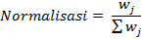
Setelah bobot diberikan kemudian hitung normalisasi bobot criteria dari setiap criteria dengan cara skor pada bobot criteria dibagi total bobot criteria sesuai dengan persamaan (1) berikut

.........................................(1)

Keterangan :

: Skor Bobot criteria
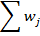
: Total Bobot Semua Criteria

- Berikan skor criteria untuk masing-masing alternatif. Skor kroteria ini bisa berisi data kualitatif ataupun data kuantitatif (angka). Jika data masih berbentuk kualitatif, maka data akan dijadikan data berupa angka / kuantitatif terlebih dahulu dengan membuat nilai parameter pada criteria.
- Hitung nilai utility dengan mengubah skor criteria untuk setiap criteria menjadi skor criteria data standar. Untuk criteria dengan kategori keuntungan (benefit) dihitung dengan persamaan (2) sebagai berikut
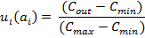
..................................(2)

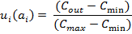
Sedangkan criteria dengan kategori biaya (cost) dihitung dengan persamaan (3) sebagai berikut
..................................(3)

ui (ai ) : skor utility criteria ke-i
Cout : skor criteria ke-i
Cmax : skor criteria maksimum
Cmin : skor criteria minimum
- Menghitung nilai akhir dengan menjumlahkan total hasil perkalian dari hasil normalisasi bobot criteria angka yang diperoleh dari normalisasi
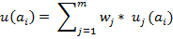
skor criteria data standar dengan skor normalisasi bobot criteria, seperti pada persamaan (4) berikut
......................................(4)
Keterangan :
u(ai) : nilai akhir alternatif
wj : hasil normalisasi pembobotan criteria
uj(ai) : hasil nilai dari utiliti
- Perengkingan
Peragkingan adalah proses pengurutan nilai akhir dari terbesar ke terkecil. Alternatif terbaik adalah alternatif yang memperoleh nilai terbesar.

Contoh Kasus

Contoh data sample yang digunakan pada penelitian ini adalah data masyarakat pematangsiatar sebanyak 9 orang. Berikut sample data masyarakat yang digunakan pada penelitian ini, yaitu :

Tabel 2.2 : Sample Masyarakat
No | NIM | Nama | Pendapatan Orang Tua | Jumlah Tanggungan
1 | 201701030082 | Abdullah ahmad | 3.5 | 4
2 | 201701030096 | Dya ayu safitri | 3 | 3
3 | 201701030031 | Sri wulandika | 2 | 2
4 | 201701030050 | Frendy sisko | 2 | 3
5 | 201701030041 | Alvin | 2 | 3
6 | 201701030065 | Nuranisa | 2.5 | 2
7 | 201701030026 | Pipit | 2.7 | 2
8 | 201701030027 | Rika | 1.2 | 2
9 | 201701030008 | Devi | 1.3 | 2

Perhitungan manual
Pada sistem yang sedang berjalan dalam menentukan penerima bantuan hanya menggunakan satu criteria, yaitu memiliki administrasi lengkap.
Berikut merupakan hasil rekomendasi penerima bantuan
Tabel 2.3 : Rekomendasi penerima Bantuan
No | NIM | Nama
1 | 201701030082 | Abdullah ahmad
2 | 201701030096 | Dya ayu safitri
3 | 201701030031 | Sri wulandika
4 | 201701030050 | Frendy sisko
5 | 201701030041 | Alvin
6 | 201701030065 | Nuranisa
7 | 201701030026 | Pipit
8 | 201701030027 | Rika
9 | 201701030008 | Devi

- perhitungan dengan Sistem Pendukung Keputusan Metode SMART
- Menentukan Kriteria :
Pada penelitian ini, penulis menggunakan dua criteria yaitu Pendapatan Orang Tua dan Jumlah Tanggungan.
- Pendapatan orang tua
Tabel 2.4 : Kriteria Pendapatan Orang Tua
Pendapatan Orang Tua | Nilai | Bobot
<= 1.500.000 | 100 | 30%
1.500.001 – 2.500.000 | 80 | 30%
2.500.001 – 3.500.000 | 60 | 30%
3.500.001 – 4.500.000 | 40 | 30%
>4.500.000 | 20 | 30%

- Jumlah Tanggungan
Tabel 2.5 : Kriteria Jumlah Tanggungan
Jumlah Tanggungan | Nilai | Bobot
>= 5 | 100 | 30%
4 | 80 | 30%
3 | 60 | 30%
2 | 40 | 30%
1 | 20 | 30%

- Normalisasi
Tabel 2.6 : Normalisasi
Kriteria | Bobot | Normalisasi
Pendapatan Orang Tua | 30% | 0,3
Jumlah Tanggungan | 30% | 0,3

- Menentukan Nilai Utility :
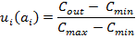
Rumus :

Cmax = 5 = 100. (5-1)/(5-1)
Cmax = 1 = 100
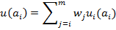
- Menentukan Nilai Akhir :
Rumus :

Pencarian Nilai Akhir dari sample :
- Abdullah Ahmad :
C1 = 60
C2 = 80
= (60*0,3) + (80*0,3)
= 18 + 24
= 42
- Dyah ayu safitri
C1 = 40
C2 = 60
= (40*0,3) + (60*0,3)
= 12 + 18
= 30
- Sri Wulandika
C1 = 80
C2 = 40
= (80*0,3) + (40*0,3)
= 24 + 12
= 36
- Frendy sisko simbolon
C1 = 80
C2 = 60
= (80*0,3) + (60*0,3)
= 24 + 18
= 42
- Alvin sijabat
C1 = 80
C2 = 60
= (80*0,3) + (60*0,3)
= 24 + 18
= 42
- Nurannisa pulungan
C1 = 80
C2 = 40
= (80*0,3) + (40*0,3)
= 24 + 12
= 36
- Pipit mutiara dewi
C1 = 60
C2 = 40
= (60*0,3) + (40*0,3)
= 18 + 12
= 30
- Rika asma dewi
C1 = 100
C2 = 40
= (60*0,3) + (40*0,3)
= 30 + 12
= 42
- Devi monika
C1 = 100
C2 = 40
= (100*0,3) + (40*0,3)
= 30 + 12
= 42
Berikut ini merupakan hasil dari perhitungan nilai akhir di atas. Sehingga di dapat lah ranking tertinggi sampai terendah dari setiap dari setiap calon penerima bantuan.
Tabel 2.7 : Hasil Perhitungan Nilai Akhir
No | NIM | Nama | Nilai Akhir | Ranking
1 | 201701030082 | Abdullah ahmad | 42 | 1
2 | 201701030096 | Dya ayu safitri | 30 | 8
3 | 201701030031 | Sri wulandika | 36 | 6
4 | 201701030050 | Frendy sisko | 42 | 2
5 | 201701030041 | Alvin | 42 | 3
6 | 201701030065 | Nuranisa | 36 | 7
7 | 201701030026 | Pipit | 30 | 9
8 | 201701030027 | Rika | 42 | 4
9 | 201701030008 | Devi | 42 | 5

    - Siklus Pengembangan Sistem
Model SDLC air terjun (waterfall) sering juga disebut model sekuensial linier (Sequential Linier) atau alur hidup klasik (Classic Life Cycle). Model air terjun menyediakan pendekatan alur hidup perangkat lunak secara sekuensial atau terurut dimulai dari analisis, desain, pengodean, pengujian, dan tahapan pendukung (Support). Berikut adalah gambar model waterfall:
Ananlisi Sistem

Studi kelayakan

Analisi Kebutuhan
Desain Sistem

Perancangan komseptual

Perancangan fisik
Implementasi Sistem

Pemrograman dan

Pengujian konversi
Operasi Dan

pemeliharan

Kebutuhan Sistem

Perubahan

Lingkup/

Kebutuhan

Desain Sistem

Kesalahan atau
Masalah Yang tidak
memungkinpkan
Implementasi dilaksanakan

Sistem Siap
beroperasi

Implementasi kurang lengkap
MandiriAda permintaan baru

Gambar 2.2 : Siklus Hidup Pengembangan System (Waterfall)

    - Perancangan Fisik
Perancangan fisik adalah proses membuat deskripsi implementasi basisdata, mendeskripsikan struktur penyimpanan dan metode pengaksesan untuk meningkatkan efektifitas. [7]
Beberapa hasil akhir Konsep fisik:
- Konsep Keluaran, Berupa : Laporan dan Dokumen.
- Konsep Masukkan, berupa : konsep layar untuk pemasukkan data.
- Konsep Antarmuka Pemakai dan Sistem : berupa rancangan interaksi antar muka dan sistem, misalnya berupa menu, icon dan lain-lain.
- Konsep platform : Konsep menentukan hardware dan software yang dipakai.
- Konsep BasisData : Berupa konsep berkas dalam basis data termasuk pemillihan kemampuan.
- Konsep Modul : Berupa rancangan program yang dilengkapi dengan algoritma.
- Dokumentasi : Berupa hasil dan tahap desain secara fisik.
- Konsep Pengujian : Berupa rencana yang di pakai untuk menguji sistem.
- Konsep Konversi : Konsep untuk menetapkan system yang baru.
Bagan alir dapat didefinisikan sebagai rencana yang dikerjakan sistem. Pekerjaan secara keseluruhan dari sistem.

Tabel 2.8 : Bagan Alir Sistem
No | Nama Simbol | Simbol | Keterangan
1. | Simbol Terminal |  | Menunjukkan untuk memulai dan mengakhiri  suatu proses
2. | Simbol Dokumen |  | Menunjukkan dokumen input danoutput.
3. | Simbol Kegiatan Manual |  | Menunjukkan Pekerjaan  Manual
4. | Simbol Simpanan Offline | 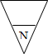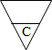 | Menunjukkan file non- komputer yang diarsip urut angka (numerical), huruf (alphabetical), tanggal (Chronogical)
5. | Simbol Kartu Plong |  | Menandai input dan output yang menggunakan kartu  plong.
6. | Simbol Proses |  | Menunjukkan kegiatan proses
7. | Simbol Operasi Luar |  | Menunjukkan operasi yang dilakukan diluar proses sistem
8. | Simbol Pengurutan Offline |  | Menunjukkan Proses urut data di luar proses sistem
9. | Simbol Pita Magnetik |  | Menunjukkan operasi yang dilakukan di luar proses operasisistem
10. | Simbol Hard Disk |  | Input dan Output  menggunakan pita sistem
11. | Simbol Diskette |  | Menunjukkan input dan output  mengunakan hardisk
12. | Simbol Drum Magnetik |  | Menunjukkan input dan output  menggunakan sistem
13. | Simbol Pita Keras |  | Input dan Output  Menggunakan pita keras
14. | Simbol Keyboard |  | Input dan Output  menggunakan on-line keyboard
15. | Simbol Display |  | Menunjukkan Output yang ditampilkan dimonitor
16. | Simbol Pita Kontrol |  | Penggunaan pita sistem (control tape) dalam batch control total untuk  pencocokan di proses batch
17. | Simbol Hubungan Komunikasi |  | Proses transmisi data melalui  Channel Komunikasi
18. | Simbol Garis Alir |  | Digunakan Untuk menunjukkan arusProses
19. | Simbol Penjelasan |  | Menunjukkan penjelasan dari  suatu proses
20. | Simbol Penghubung |  | Penghubung ke halaman yang Sama

Untuk mempermudah penggambaran sebuah sistem perlu diperhatikan lingkungan fisik dimana data akan disimpan, maka dibutuhkan Diagram Arus Data (DAD) atau Data FlowDiagram (DFD), berikut simbol-simbolnya.

- Eksternal Entity(Kesatuan Luar) atau Boundary (Batas Sistem)
Kesatuan luar (external entity) merupakan kesatuan (entity) dilingkungan luar sistem yang berupa orang, setiap sistem pasti mempunyai batas sistem (boundary). Dilingkungan luarnya yang akan memberikan input atau menerima output dari sistem. [7]

Gambar 2.3 : Notasi Kesatuan Luar

- Data Flow (Arusdata)
Arus data ini menunjukkan arus atau alir data yang dapat berupa masukkan atau hasil dari proses sistem. [7]

Gambar 2.4 : Notasi Arus Data
- Proses (Process)
Proses adalah kegiatan atau kerja yang dilakukan orang, mesin atau sistem dari hasil suatu arus data yang masuk kedalam proses. [7]

Nama

Gambar 2.5 : Notasi Proses

4. Data Store (Simpanan Data)
“Simpanan Data pada DFD disimbolkan dengan garis horizontal parallel yang tertutup salah satu ujungnya”.[7]

Media | Nama data store
Gambar 2.6 : Notasi Simpanan Data

    - Implementasi Sistem
Suatu Proses untuk menempatkan sistem informasi baru ke dalam sistem yang sudah lama.
Ada 4 tahapan dalam implementasi sistem:
- Membuat dan menguji basis data dan jaringan
- Membuat dan menguji program
- Memasang dan menguji sistem baru
- Mengirim sistem baru ke dalam sistem alamat
Dari ke empat proses diatas telah diseleksi dan dipilih, kemudian sistem dapat diimplementasikan dan dioperasikan.

    - Operasi dan Pemeliharaan
Setelah masa sistem berjalan sepenuhnya menggantikan sistem yang sudah lama, sistem memasuki pada tahapan operasi dan pemeliharaan. Pemeliharaan perangkat lunak terbagi tiga:
- Pemeliharaan Perfektif\
Pemeliharaan ini berupa perubahan aplikasi untuk menyesuaikan diri terhadap lingkungan perangkat keras dan lunak.
- Pemeliharaan Adaptif
Pemeliharaan ini berupa perubahan aplikasi untuk menyesuaikan diri terhadap lingkungan perangkat keras dan lunak.
- Pemeliharaan Korektif
Pemeliharaan ini berupa pembetulan atas kesalahan-kesalahan yang ditemukan pada saat sistem berjalan.
  - Teknik Pengujian Sistem
    - White Box
White Box Merupakan metode pengujian perangkat lunak di mana struktur internal diketahui untuk menguji siapa yang akan melakukan pengujian perangkat lunak. Pengujian ini membutuhkan pengetahuan internal tentang kemampuan sistem dan pemrograman.
Pengujian white box bisa dilakukan dengan pengujian basis path, metode ini merupakan salah satu teknik pengujian struktur sistem untuk menjamin semua statemen dalam setiap jalur independen program dieksekusi minimal 1 kali. Perhitungan jalur independen dapat dilakukan melalui metric Cyclomatic complexity. Sebelum menghitung nilai dari cyclomatic Complexity, harus diterjemahkan desain prosedural ke grafik alir, kemudian dibuat flow graphnya, seperti gambar dibawah ini. [7]
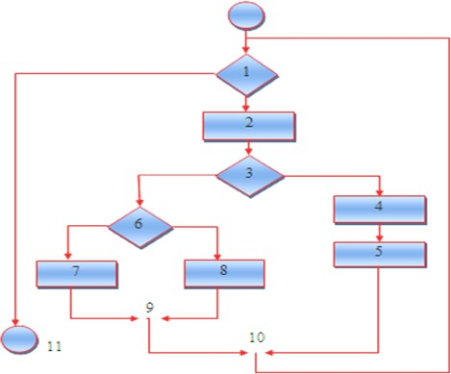

Gambar 2.7 : Bagan Alir

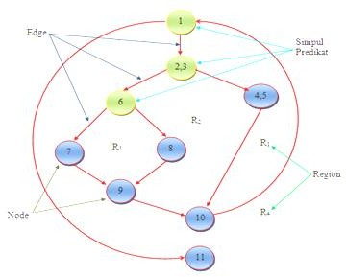
Gambar 2.8 : Grafik Alir
- Node adalah lingkaran yang mempresentasikan satu atau lebih statement procedural
- Edge adalah anak panah pada grafik alir,
- Region adalah area yang membatasi edge dan node,
- Simpul Predikat adalah simpul atau node yang berisi kondisi yang ditandai dengan dua atau lebih edge yang berasal darinya,
Dari gambar flowgraph di atas didapat:
Path 1 = 1-11
Path 2 = 1 – 2 – 3 – 4 – 5 – 10 – 1 – 11
Path 3 = 1 – 2 – 3 – 6 – 8 – 9 – 10 – 1 –11
Path 4 = 1 – 2 – 3 – 6 – 7 – 9 – 10 – 1 –11
Path 1,2,3,4 yang telah didefinisikan diatas merupakan basis set untuk diagram alir, Cyclomatic complexity digunakan untuk mencari jumlah path dalam satu flowgraph. Dapat dipergunakan rumus sebagai berikut:
1. Jumlah region grafik alir sesuai dengan cyclomatic complexity,
2. Cyclomatic complexity V(G) untuk grafik alir dihitung dengan rumus:
V(G) = E-N+2 ...........................(1)
Dimana:
E = jumlah edge pada grafik alir
N = jumlah node pada grafik alir
- Cyclomatic complexity V(G) juga dapat dihitung dengan rumus:
V(G) = P + 1 .........................(2)
Dimana P = jumlah Predicate node pada grafik alir
Dari gambar di atas dapat dihitung cyclomatic complexity.
1) Flowgraph mempunyai 4 region
2) V(G) = 11 edge – 9 node + 2 = 4
3) V(G) = 3 predicate node + 1 = 4
Jadi cyclomatic complexity untuk flowgraph adalah 4

    - Black Box
Black box testing adalah menguji perangkat lunak dari segi spesifikasi fungsional tanpa menguji desain dan kode program. Pengujian dimaksudkan untuk mengetahui apakah fungsi-fungsi, masukan, dan keluaran dari perangkat lunak sesuai dengan spesifikasi yang dibutuhkan. [7]

Pengujian Black-Box berusaha menemukan kesalahan dalam kategori:
- Fungsi tidak benar atau hilang
- Kesalahan antar muka
- Kesalahan pada struktur data (pengaksesan basis data)
- Kesalahan inisialisasi dan akhir program
- Kesalahan informasi
Pengujian ini yang dituju adalah persyaratan fungsional perangkat lunak sebagai berikut:
- Pengujian Graph-based: yaitu melakukan presentasi target (sistem New File, layar baru dengan attributnya), link (hubungan antar objek), node- weight (missal nilai data tertentu seperti atribut layar, perilaku), dan link- weight (karakteristik suatu link, misal menu select).
- Equivalence Partitioning: membagi wilayah input untuk pengujian agar didapati kesalahan (misal kelompok data karakter, atau atribut yang lain).
- Analisis Nilai Batas: menguji berdasarkan nilai batas wilayah input. Pengujian perbandingan: disebut juga pengujian back-to-back yang diterapkan pada suatu versi perangkat lunak.

  - Analisis Kebutuhan Perangkat Lunak
Analisis kebutuhan perangkat lunak (software requirements analysis) merupakan aktivitas awal dari siklus hidup pengembangan perangkat lunak. Untuk proyek-proyek perangkat lunak yang besar, analisis kebutuhan dilaksanakan setelah tahap rekayasa sistem/informasi dan software project planning. [7]
- Desain Sistem Secara Umum (General Sistem Design)
Tujuan dari desain sistem secara umun adalah memberikan gambaran kepada user tentang sistem yang baru. Desain sistem secara umum merupakan persiapan dari desain terinci. Tahap desain sistem secara umum dilakukan setelah tahap analisis sistem selesai dilakukan dan hasil analisis disetujui oleh manajemen.
- Desain Sistem Secara Rinci (Detailed SistemDesign)
- Desain Input Terperinci
Masukkan (Input) merupakan proses awal dimulainya informasi. Data hasil transaksi merupakan masukkan untuk sistem informasi.
- Desain Output Terperinci
Bentuk dari laporan yang dihasilkan oleh sistem informasi, yang paling digunakan adalah dalam bentuk sistem dan berbentuk grafik ataubagan.
- Desain Database Terinci
Yaitu desain keperluan database secara rinci yang meliputi penggunaan file-file dalam suatu sistem informasi. Basis data (database) merupakan kumpulan dari data yang saling berhubungan satu dengan yang lainnya, tersimpan di perangkat keras sistem dan digunakan perangkat lunak untuk memanipulasinya. Database merupakan salah satu komponen yang penting dalam sistem informasi bagi para pemakai.
- Desain Teknologi
- Perangkat Keras (Hardware), yang terdiri dari alat masukkan, pemroses, alat output dan Penyimpanan luar.
- Perangkat Lunak (Software), yang terdiri dari perangkat sistem operasi (Operating Sistem), perangkat lunak bahasa (Language Software) dan perangkat lunak (Application Software).
- Sumber Daya Manusia (Brainware), misalnya operator sistem, pemrograman, spesialis telekomunikasi, sistem analisis dan sebagainya.
- Desain Model
Terbagi atas desain model secara luas dan terinci.

  - Perangkat Lunak Pendukung
Perangkat lunak pendukung yang digunakan untuk membuat sistem ini yaitu PHP yang digunakan untuk membuat Website, MySQL sebagai basis data, dan untuk kreasi webnya menggunakan Dreamweaver
- PHP adalah bahasa server-side-scripting yang menyatu dengan HTML untuk membuat halaman web yang dinamis. Karena PHP merupakan server-side-scripting maka sintaks dan perintah-perintah PHP akan di esksekusi diserver kemudian hasilnya akan dikirimkan ke browser dengan format HTML.[8]
Kelebihan-kelebihan PHP dari program lain;
- Gratis / free karena PHP merupakan open source software
- Tidak mudah terkena virus.
- Sangat multi user.
- Sangat stabil di semua operating system.

Gambar 2.9 : PHP

- MySQL
Berikut pengertian MySQL menurut para ahli :
- My Structure Query Languange adalah salah satu jenis database server yang sangat terkenal dan banyak digunakan untuk membangun aplikasi web yang menggunakan database sebagai sumber dan pengolahan datanya.
- Menurut Arief Tahun 2012, MySQL merupakan RDBMS (atau server database) yang mengola database dengan cepat menampung dalam jumlah sangat besar dan dapat diakses oleh banyak user. [8]


Gambar 2.10 : MySQL

- Adobe Dreamweaver
Menurut Sadeli Tahun 2013, Adobe Dreamweaver merupakan suatu perangkat lunak web editor keluaran Adobe Sistem yang digunakan untuk membangun dan mendesain suatu website dengan fitur-fitur yang menarik dan kemudahan dalam penggunaannya.
anda dapat membuat dan menggunakan Style dalam CSS dengan mudah dan fleksibel merupakan suatu perangkat lunak web editor keluaran Adobe Sistem yang digunakan untuk membangun dan mendesain suatu website dengan fitur-fitur yang menarik dan kemudahan dalam penggunaannya. [9].

Gamb ar 2.11 Adobe Dreamweaver

- Adobe Photoshop
Adobe photoshop, atau biasa disebut Photoshop, adalah perangkat lunak editor citra buatan Adobe System yang di khususkan untuk pengeditan foto/gambar dan pembuatan efek. [10]
Perangkat lunak ini banyak digunakan oleh fotographer digital untuk mengajarkan keterampilan mengedit foto/gambar Aplikasi Adobe Photoshop dapat dilakukan secara kongkrit dan jelas karena langgsung di praktekkan.


Gambar 2.12 : Adobe Photoshop
- Ms Visio
Microsoft visio merupakan sebuah program aplikasi komputer yang sering digunakan dalam membuat diagram, seperti diagram alir (flowchart), brainstorm, dan skema jaringan yang dirilis oleh Microsoft Corporation. Aplikasi ini menggunakan grafik vektor dalam membuat diagram-diagramnya. [11]



Gambar 2.13 : Ms Visio

  - Kerangka Pemikiran
MASALAH
- Bagaimana menerapkan metode SMART untuk proses seleksi awal penerima bantuan bibit jagung di Desa Manawa ?
- Apakah sistem pendukung keputusan menggunakan metode SMART dapat mempermudah proses seleksi awal penerima bantuan bibit jagung?
PEMODELAN
Pengumpulan Data
Kriteria Penerima Bantuan
Studi literatur, Wawancara & Observasi
1
- Petani
- Kelompok Bibit Jagung
- Mempunyai Lahan
- Penggarapan Lahan

2
PENGEMBANGAN SISTEM
TUJUAN
Analisis Sistem
- Sistem Berjalan
- Sistem yang Di usulkan
Desain Sistem
- Desain Model
- Desain User Interface : Input, Output, Menu Utama, Database
Pengujian Sistem
White Box & Black Bax
- Untuk mengetahui apakah sistem pendukung keputusan ini dapat digunakan untuk membantu mengoptimalkan proses seleksi awal penerima bantuan bibit jagung
- Menerapkan sistem pendukung keputusan seleksi awal penerima bantuan bibit jagung menggunakan metode SMART yang dapat di implementasikan di Desa Manawa
3
4
6
Pembangunan Sistem
PHP, MySQL, Adobe Dreamweaver, Photoshop, visio
5

Gambar 2.13 Kerangka Pemikiran.

BAB III

METODE PENELITIAN

  - Jenis, Metode, Subjek, Objek, Waktu, dan Lokasi Penelitian
Di pandang dari tingkat penerapannya, maka penelitian ini merupakan penelitian terapan. Di pandang dari jenis informasi yang diolah, maka penelitian ini merupakan penelitian kuantitatif. Di pandang dari perlakuan terhadap data, maka penelitian ini merupakan penelitian konfirmatori
Penelitian ini menggunakan metode penelitian Simple Multi Attribut Rating Technique Dengan demikian jenis penelitian ini adalah penelitian korelasional.
Subjek penelitian ini adalah “Sistem Pendukung Keputusan Penerima Bantuan Bibit Jagung Menggunakan Metode SMART”. Penelitian ini di mulai dari tanggal 24 September 2021 s/d 30 September 2021 yang berlokasi pada Jl. Trans Sulawesi Bawah, Desa Manawa, Kecamatan Patilanggio, Kabupaten Pohuwato, Provinsi Gorontalo
  - Pengumpulan Data
Metode pengumpulan data yang digunakan dalam menyusun serta melengkapi data yang ada. Adapun metode yang di gunakan adalah :
- Studi Literatur
Pada metode ini dilakukan dengan mempelajari berbagai literature melalui pengumpulan dokumen dari beberapa referensi, buku-buku, sumber internet yang berkaitan dengan tema penelitian.
- Wawancara
Pada metode ini dilakukan proses wawancara kepada staf Kantor Desa Manawa atau orang maupun sumber lain yang mendukung dan diperlukan untuk merancang sistem yang berkaitan dengan tema penelitian. Hal ini bertujuan untuk mendapatkan data yang tidak ditemukan pada tahap studi

literatur. Selanjutnya data-data yang telah dikumpulkan disusun menjadi basis aturan yang akan digunakan dalam sistem pendukung keputusan. Pada metode ini dilakukan wawancara pada staf Kantor Desa Manawa
- Observasi
Observasi Teknik pengumpulan data dengan melakukan pengamatan langsung. Tempat observasi dilakukan di Kantor Desa Manawa.

    - Analisis Kebutuhan Input
Input yang digunakan untuk melakukan proses pengambilan keputusan dari beberapa alternatif adalah sebagai berikut.
Tabel 3.1 : Analisis Kebutuhan Input
No | Kriteria
1 | Administrasi
2 | Ekonomi

    - Analisis Kebutuhan Output
Jumlah bantuan yang akan diberikan kepada Penerima tergantung nilai yang dihasilkan dari perhitungan Simple Multi Attribut Rating Technique dengan nilai maksimal 1.000.000/ tahun. Penerima yang akan diberikan bantuan yang memiliki kriteria-kriteria yang sudah ditentukan.

  - Analisis Sistem
Sesuai dengan metode Simple Multi Attribut Rating Technique yang digunakan untuk sistem pendukung keputusan penerima bantuan bibit jagung pada masyarakat, yang cara prediksi kelayakan penerima bantuan berdasarkan perhitungan, tahapan-tahapan tersebut disimpulkan suatu jumlah yang dihitung berdasarkan nilai metode SMART sesuai dengan data-data yang diperolah dari Kantor Desa yang menjadi sample. Data yang diambil adalah data variabel yang menjadi unsur pengambilan kebijakan.
Adapun unsur yang digunakan dalam berkas penerima bantuan bibit jagung diantaranya yaitu :

Seleksi administrasi pada tahap ini dilakukan verifikasi data yang berkenaan dengan masyarakat tersebut

Seleksi ekonomi orang tua, tahap ini dilakukan verifikasi data menyangkut masalah pendapatan orang tua sesuai dengan kriteria kurang mampu

Tahap Desain

Pada tahap ini dilakukan desain sistem yakni desain output, desain input, desain database, desain teknologi dan desain model :

Desain Output

Keluaran (output) adalah produk dari Aplikasi yang dapat dilihat.Output dapat berupa hasil media keras seperti kertas, atau dapat pula hanya berupa tampilan informasi pada layar monitor.

Desain Input

Desain input adalah dokumen dasar yang digunakan untuk menangkap data, kode-kode input yang digunakan. Untuk tahap rancangan input secara umum yang perlu dilakukan analisis adalah mengidentifikasi terlebih dahulu input yang akan didesain secara rinci tersebut.

Desain Database

Merupakan kumpulan data yang saling berhubungan satu dengan yang lain. Database salah satu komponen yang penting di sistem informasi, karena berfungsi sebagai penyedia informasi bagi pemakainya.

Desain Teknologi

Desain teknologi terbagi dua yaitu desain teknologi secara umum dan terinci. Dipergunakan dalam menerima input, menjalankan model, menyimpan dan mengakses data, menghasilkan dan mengirimkan keluaran dan membantu pengendalian dari sistem secara keseluruhan.

Desain Model

Merupakan tahapan yang lebih berfokus pada spesifikasi detail berbasis sistem. Pada tahap ini digunakan Data Flow Diagram (DFD), dimana memodelkan persyaratan logis dari suatu sistem informasi.

Sumber Data

Sumber data yang digunakan adalah data primer yaitu data yang diperoleh dari hasil analisis.

Alat

Alat yang digunakan adalah Data Flow Diagram (DFD) termasuk dalam hal proses fisik, aliran data fisik serta data store fisik.

Pengolahan Data

Pada sistem ini terdapat terdapat dua aktor yang terlibat yaitu admin dan pengguna atau user. Secara garis besar, proses-proses yang dilakukan pengguna dapat digambarkan dalam bentuk flowchart
Input Nilai Sub Kriteria
Normalisasi Bobot
$$\frac{w_{j}}{\sum{w_{j}}}$$
Input Kriteria
Dan bobotnya
Star
SMART

Hitung Nilai Utility untuk setiap Kriteria
$$u_{i}\left(a_{i}\right)=100\frac{(C_{out}-C_{min})}{(C_{max}-C_{min})}\%$$
Hitung Nilai Akhir
$$u_{i}\left(a_{i}\right)=\sum_{J=1}^{m}{w_{j}}u_{j}(a_{i})$$

Hasil Keputusan

End

Gambar 3.1 : Flowchart perhitungan menggunakan metode Smart

Pengembangan Sistem

Prosedur atau langkah-langkah pokok dalam pembuatan sistem pendukung keputusan menggunakan metode Simple Multi Attribute Rating Technique untuk menentukan penerima bantuan bibit jagung dengan menggunakan alat bantu yaitu:

MySQL;

PHP;

Adobe Dreamweaver

Mozila Firefox; dst.

Pengujian Sistem

Adapun metode pengujian sistem, diantaranya :

Pengujian oleh user

Pengujian terhadap aplikasi dengan tujuan memastikan fungsionalitas aplikasi dapat berjalan sama seperti yang diharapkan. Aplikasi akan dilakukan oleh user dan kemudian user akan mengisi kuesioner.

Validasi

Sistem yang telah dibuat akan di validasi oleh user yang bertugas dengan membandingkan presentase hasil sistem dan hasil dari cara manual.

White Box Testing

Software yang telah direkayasa kemudian diuji dengan metode White Box Testing pada kode program proses penerapan metodenya/modelnya. Kode program tersebut dibuatkan flowchart programnya, kemudian dipetakan kedalam bentuk flowgraph (bagan alir control) yang tersusun dari beberapa node dan edge. Berdasarkan flowgraph , ditentukan jumlah region dan cyclomatic complexity (CC). Apabila independent path = V(G) = (CC) = region, dimana setiap path hanya dieksekusi sekali dan sudah benar maka sistem dinyatakan efesien dari segi kelayakan logika pemograman.

Black Box Testing

Selanjutnya software diuji pula dengan metode Black Box Testing yang focus pada keperluan fungsional dari software dan berusaha untuk menentukan kesalahan dalam beberapa kategori, diantaranya :

Fungsi-fungsi yang salah atau hilang;

Kesalahan Interface;

Kesalahan dalam struktur data atau akses basis data external;

Kesalahan performa;

Kesalahan inisialisasi dan terminasi. Jika sudah tidak ada kesalahan-kesalahan tersebut, maka sistem dinyatakan efesien dari segi kesalahan komponen-komponen sistem.

BAB IV
ANALISIS DAN DESAIN SISTEM

4.1 Pengumpulan Data
Pengumpulan data dikumpulkan melalui observasi di tempat yang memiliki hubungan dengan data yang diperlukan yaitu di Kantor Desa Manawa

4.1.1 Kriteria dan Sub Kriteria
Tabel 4. 1: Kriteria dan Sub Kriteria
No | Kriteria | Subkriteria | Tingkat Kepentingan
1 | Petani | Ya | 5
1 | Petani | Tidak | 1
2 | Kelompok Bibit Jagung | Tergabung | 5
2 | Kelompok Bibit Jagung | Tidak Tergabung | 1
3 | Penggarapan Lahan | Ya | 5
3 | Penggarapan Lahan | Tidak | 1
4 | Mempunyai Lahan | Ya | 5
4 | Mempunyai Lahan | Tidak | 1

4.1.2 Normalisasi Bobot Kriteria
Tabel 4. 2: Normalisasi Bobot Kriteria
No | Kriteria | Bobot | Normalisasi
1 | Petani | 30 | 0.3
2 | Kelompok Bibit Jagung | 28 | 0.28
3 | Penggarapan Lahan | 17 | 0.17
4 | Mempunyai Lahan | 25 | 0.25

4.1.3 Niliai Tingkat Kepentingan
Tabel 4. 3: Nilai Tingkat Kepentingan
No | Tingkat Kepentingan | Nilai
1 | Tidak Prioritas | 1
2 | Kurang Prioritas | 2
3 | Cukup Prioritas | 3
4 | Prioritas | 4
5 | Sangat Prioritas | 5

4.2 Hasil Pemodelan
Untuk hasil pemodelan dilakukan beberapa tahap, untuk tahap pertama yaitu penentuan nilai awal setiap alternative untuk setiap kriteria. Nilai Awal diambil dari penilaian setiap alternative untuk setiap kriteria. Berikut table nilai awal
Tabel 4. 4: Nilai Awal
No | Kode | Alternatif | Petani | Kelompok Bibit Jagung | Penggarapan  Lahan | Mempunyai Lahan
1 | AA2 | Bukit Tani | 5 | 5 | 4 | 5
2 | AA1 | Harapan Tani | 1 | 1 | 1 | 5
3 | AA3 | Sinar Tani | 5 | 5 | 4 | 1
4 | AA4 | Sinar Cahaya | 5 | 5 | 1 | 5

Tabel 4. 5: Nilai Utility
No | Kode | Alternatif | Petani | Kelompok Bibit Jagung | Penggarapan  Lahan | Mempunyai  Lahan
 |  |  | 0.3 | 0.28 | 0.17 | 0.25

1 | AA2 | Bukit Tani | 1,00 | 1,00 | 1,00 | 1,00
2 | AA1 | Harapan Tani | 0,00 | 0,00 | 0,00 | 1,00
3 | AA3 | Sinar Tani | 1,00 | 1,00 | 1,00 | 0,00
3 | AA4 | Sinar Cahaya | 1,00 | 1,00 | 0,00 | 1,00

Tabel 4. 6: Nilai Terbobot
No | Kode | Alternatif | Petani 0.3 | Kelompok Bibit Jagung 0.28 | Penggarapan  Lahan  0,17 | Mempunyai Lahan  0,25
1 | AA2 | Bukit Tani | 0,30 | 0,28 | 0,17 | 0,25
2 | AA1 | Harapan Tani | 0,00 | 0,00 | 0,00 | 0,25
3 | AA3 | Sinar Tani | 0,30 | 0,28 | 0,17 | 0,00
3 | AA4 | Sinar Cahaya | 0,30 | 0,28 | 0,00 | 0,25

Tabel 4. 7:Hasil Akhir
No | Kode | Alternatif | SKOR
1 | AA2 | Bukit Tani | 1,00
2 | AA4 | Sinar Cahaya | 0,83
3 | AA3 | Sinar Tani | 0,75
3 | AA1 | Harapan Tani | 0,25

4.3 Hasil Pengembangan Sistem

4.3.1 Analisis Sistem
Analisis sistem adalah sebuah sistem informasi yang di jabarkan secara utuh ke dalam berbagai macam bagian-bagian komponennya, yang bertujuan untuk kita bisa mengidentifikasi atau mengevaluasi berbagai macam masalah ataupun hambatan yang akan timbul pada sistem sehingga nantinya dapat kita lakukan penanggulangan, perbaikan atau juga pengembangan.
Tahap analisis dikerjakan setelah tahap perencanaan sistem dan sebelum tahap desain sistem. Ditahapan ini merupakan tahapan yang begitu penting, karena apabila kesalahan yang terjadi ditahap ini maka akan menyebabkan kesalahan pada setiap tahap berikutnya.
Pada tahap analisis pengembang sistem mengidentifikasi pada masalah-masalah yang terjadi kepada pengguna secara mendalam dengan melakukan dekomposisi terhadap objek-objek yang terlibat pada sistem, dan berusaha menemukan solusi yang tepat berdasarkan data-data yang memungkinkan untuk melakukan pengembangan sistem sesuai kebutuhan.
Gambar 4. 1: Sistem Berjalan

Analisa Sistem Yang Diusulkan
Setelah menganalisa sistem yang berjalan/ sistem lama, maka tahapan dapat dilanjutkan dengan menganalisa sistem yang baru. Analisa dalam pembuatan sistem ini menggunakan metode SMART serta penggunaan Data Flow Diagram (DFD) untuk menganalisa kebutuhan sistem. Data-data yang dibutuhkan untuk memulai pembuatan sistem ini dimasukkan kedalam analisa data sistem untuk menentukan Penerima Bantuan Bibit Jagung di Kantor Desa Manawa. Dengan adanya analisa tersebut, dapat diketahui kebutuhan sistem dengan meneliti darimana data berasal, bagaimana aliran data menuju sistem, bagaimana operasi sistem yang ada dan hasil akhirnya.
Gambar 4. 2: Analisis Sistem yang Diusulkan

4.3.2 Diagram Konteks
Gambar 4. 3: Diagram Konteks

4.3.3 Diagram Berjenjang
Gambar 4. 4 : Diagram Berjenjang

4.3.4 Diagram Arus Data

4.3.4.1 DAD Level 0
Gambar 4. 5: DAD Level 0

4.3.4.2 DAD Level 1 Proses 1
Gambar 4. 6: DAD Level 1 Proses 1

4.3.4.3 DAD Level 1 Proses 2
Gambar 4. 7: DAD Level 1 Proses 2

4.3.4.4 DAD Level 1 Proses 3
Gambar 4. 8: DAD Level 1 Proses 3

4.3.5 Spesifikasi Hadware dan Software Yang Di Rekomendasi
Dalam pengembangan sistem ini penulis menggunakan bahasa pemrograman PHP dan database MySql. Untuk implementasi sistem membutuhkan perangkat lunak atau perangkat keras dasar yang mesti digunakan untuk menjalankan program aplikasi, diantaranya :
1. Spesifikasi Hadware dan Software
Spesifikasi yang disarankan untuk komputer
- Processor setara AMD A4-3305M APU with Radeon(tm) HD Grafics 1.90 GHz atau lebih
- RAM (Memory) 2 GB atau lebih
- HDD 500 atau lebih.
- Monitor SVGA dengan Resolusi 1024 X 768
- Dan Peralatan I/O Lainnya
- Windows XP, Vista Windows 8 atau lebih
- Browser Mozilla Firefox, Internet Explorer dan Google Chrome untuk membuka Web
- Dreamwaver CS4 atau lebih

4.3.6 Kamus Data
Kamus data merupakan suatu penjelasan tertulis tentang suatu data yang berada didalam database. Berikut kamus data yang digunakan peneliti.
Tabel 4. 8: Kamus Data Pengguna
Nama Arus Data : Data Pengguna |  |  |  | Bentuk Data : Dokumen
Penjelasan : Input Data Pengguna/ Admin
No | Field Name | Type | Size | Ket
1 | Id _pengguna | Int | 11 | Id
2 | Nama | Varchar | 50 | Pengguna/user/admin
3 | Telp | Varchar | 15 | No.Tlp Pengguna
4 | Username | Varchar | 20 | Username
5 | Password | Varchar | 50 | Password
6 | Tipe | Varchar | 1 | Tipe

Tabel 4. 9: Kamus Data Alternatif
Nama Arus Data : Data Alternatif |  |  |  | Bentuk Data : Dokumen
Penjelasan : Input Data Alternatif (Masyarakat)
No | Field Name | Type | Size | Ket
1 | Id_alternatif | Int | 11 | Id Kepala Keluarga
2 | Kode | Varchar | 20 | Kode Kepala Keluarga
3 | Alternatif | Varchar | 50 | Nama Kepala Keluarga
4 | Id_periode | Int | 11 | Id Periode Calom Anggota
5 | Tgl_terdaftar | Date |  | Tanggal Input Data

Tabel 4. 10: Kamus Data Kriteria
Nama Arus Data : Data Faktor/ Kriteria |  |  |  | Bentuk Data : Dokumen
Penjelasan : Input Data Kriteria Penilaian Pemberian Bantuan
No | Field Name | Type | Size | Ket
1 | Id_kriteria | Int(primary) | 11 | Id kepala keluarga
2 | Kriteria | Varchar | 50 | Kriteria penelitian
3 | Skala | Int | 2 | Skala untuk grafik kriteria
4 | Bobot | Int | 11 | Bobot setiap kriteria
5 | Bobot_normal | Double |  | Bobot normal

Tabel 4. 11: Kamus Data Sub Kriteria
Nama Arus Data : Data Alternatif |  |  |  | Bentuk Data : Dokumen
Penjelasan : Input Data Alternatif
No | Field Name | Type | Size | Ket
1 | Id_kriteria_sub | Int | 11 | Id kepala keluarga
2 | Id_kriteria | Int | 11 | Id kriteria penilaian
3 | Kriteria sub | Varchar | 50 | Sub kriteria setiap kriteria
4 | Id_kriteria_kepentingan | Double | 11 | Kepentingan kriteria

Tabel 4. 12: Kamus Data Hasil
Nama Arus Data : Data Hasil |  |  |  | Bentuk Data : Dokumen
Penjelasan : Hasil
No | Field Name | Type | Size | Ket
1 | Id_hasil | Bigint(primary) | 20 | Id hasil
2 | Id_alternatif | Int | 11 | Id alternatif
3 | Nilai | Double |  | Nilai dari setiap alternatif

Tabel 4. 13: Kamus Data Nilai Utility
Nama Arus Data : Data Nilai Evaluasi |  |  |  | Bentuk Data : Dokumen
Penjelasan : Nilai Evaluasi
No | Field Name | Type | Size | Ket
1 | Id_nilai_utility | Int | 11 | Id nilai evaluasi
2 | Id_nilai | Int | 11 | Id nilai faktof
3 | Id_nilai kriteria | Double |  | Evaluasi
4 | Nilai_terbobot | Double |  | Weight evaluasi

Tabel 4. 14: Kamus Data Nilai Kriteria
Nama Arus Data : Data Nilai Faktor |  |  |  | Bentuk Data : Dokumen
Penjelasan : Input Nilai Faktor
No | Field Name | Type | Size | Ket
1 | Id_nilai_kriteria | Bigint (primary) | 20 | Id nilai faktor
2 | Id_alternatif | Int | 11 | Id_alternatif
3 | Id_kriteria | Int | 11 | Id Faktor periode
4 | Id_Kriteria_sub | Int | 11 | Nilai
5 | Nilai | Double |  | Nilai untuk setiap kriteria

Tabel 4. 15: Kamus Data Periode
Nama Arus Data : Data Nilai Faktor |  |  |  | Bentuk Data : Dokumen
Penjelasan : Input Nilai Faktor
No | Field Name | Type | Size | Ket
1 | Id_periode | Int (primary) | 11 | Id periode
2 | Seleksi | Varchar | 50 | Nama Seleksi
3 | Periode | Varchar | 10 | Periode seleksi

4.3.7 Desain Input Secara Umum
Tujuan dari Desain Input secara umum itu sendiri yaitu untuk memberikan gambaran secara umum kepada user tentang sistem yang baru/ sistem yang diusulkan. Desain sistem secara umum mengidentifikaikan komponen-komponen sistem informasi yang akan didesain secara rinci. Desain terinci dimaksudkan untuk pemrograman computer dan ahli yang menginplementasikan sistem.
DAFTAR INPUT YANG DIDESAIN
Untuk : Kantor Desa Manawa
Tahap : Rancangan Sistem Secara Umum
Tabel 4. 16: Daftar Input Yang Didesain
Kode Input | Nama Input | Sumber Input | Periode
01 | Data Periode | Admin | Non Periodik
02 | Data Kriteria | Admin | Non Periodik
03 | Data Sub Kriteria | Admin | Non Periodik
04 | Data Tingkat Kepentingan | Admin | Non Periodik
05 | Data Alternatif | Admin | Non Periodik
06 | Data Penilaian | Admin | Non Periodik
07 | Data Pengguna | Admin | Non Periodik

DAFTAR FILE YANG DIDESAIN
Untuk : Kantor Desa Manawa
Tahap : Rancangan Sistem Secara Umum
Tabel 4. 17: Daftar File yang didesain
Kode File | Nama File | Tipe File | Media File | Organisasi File | Field Kunci
F1 | Data Periode | Master | Hard Disk | Index | Id_periode
F2 | Data Kriteria | Master | Hard Disk | Index | Id_kriteria
F3 | Data Sub Kriteria | Master | Hard Disk | Index | Id_Kriteria_ sub
F4 | Data Tingkat Kepentingan | Master | Hard Disk | Index | Id_kriteria_ kepentingan
F5 | Data Alternatif | Transaksi | Hard Disk | Index | Id-Alternatif
F6 | Hasil Seleksi | Transaksi | Hard Disk | Index | Id_hasil
F7 | Data Pengguna | Master | Hardisk | Index | Id_pengguna

4.3.8 Desain Output Secara Umum
Tujuan dari desain sistem yaitu memberikan gambaran kepada user tentang sistem. Desain sistem sendiri merupakan persiapan dari desain terinci. Tahap desain sistem secara umum dilakukan setelah tahap analisis sistem selesai dilakukan.
DAFTAR OUTPUT YANG DIDESAIN
Untuk : Kantor Desa Manawa
Tahap : Rancangan sistem Secara Umum
Tabel 4. 18: Daftar Output yang di Desain
Kode Output | Nama Output | Tipe Output | Format Output | Media Output | Alat  Output | Distribusi | Periode
01 | Daftar Alternatif (Calon penerima) | Internal | Tabel | Kertas | Printer | Admin | Non Periodik
02 | Daftar Nilai Awal | Internal | Tabel | Kertas | Printer | Admin | Non Periodik
03 | Daftar Nilai utility | Internal | Tabel | Kertas | Printer | Admin | Non Periodik
04 | Daftar Nilai Terbobot | Internal | Tabel | Kertas | Printer | Admin | Non Periodik
05 | Daftar Skor Akhir | Internal | Tabel | Kertas | Printer | Admin | Non Periodik

4.3.9 Desain Database Secara umum
Basis data merupakan kumpulan data yang terdiri dari satu atau lebih tabel yang terintegrasi satu sama lain, dimana setiap user diberi wewenang untuk dapat mengakses (mengubah, menghapus, dll) data dalam tabel-tabel tersebut.

4.4 Desain Sistem Secara Terinci

Desain Input Secara Rinci
- Desain Input Tambah Periode
Tambahh Data Periode

Nama Kriteria :
Periode :

Simpan

Gambar 4. 9: Desain Input Tambah Periode
- Desain Input Kriteria
Tambah Data Kriteria
Nama Kriteria :
Bobot :

Batal
Simpan

Gambar 4. 10: Desain Input Kriteria
- Desain Input Sub Kriteria
Tambah Data Faktor

Kategori/Kelompok Faktor :
Sub Kriteria :
Tingkat Kepentingan :

Simpan
Batal

Gambar 4. 11: Desain Input Sub kriteria
- Desain Input Tingkat Kepentingan
Tamba Data Tingkat Kepentingan
Nama Kepentingan :
Nilai :
Batal
Simpan

Gambar 4. 12: Desain Input tingkat Kepentingan
- Desain Input Alternatif
Tambah Data Alternatif [Peserta]

Periode :
Kode :
Nama Alternatif :

Batal
Simpan

Gambar 4. 13: Desain Input Alternatif

- Desain Input Nilai Penilaian Alternatif
Imput Penilaian
Periode :
Kode :
Nama Alternatif :
Kriteria - Penilaian (Sub Kriteria)
Petani -
Kelompok Bibit Jagung -
Penggarapan Lahan -
Mempunyai Lahan -

Gambar 4. 14: Desain Input Penilaian Alternatif

4.4.2 Desain Output Secara Terinci
1. Desain Output Data Periode
Tabel 4. 19: Desain Output Data Periode
No | Seleksi | Periode
1 | Penerima Bantuan Bibit Jagung | 2021
2 | ………………………. | …………….

- Desain output Data Kriteria
Tabel 4. 20: Desain Output Data Kriteria
No | Kriteria | Bobot | Normalisasi
1 | Petani | 30 | 0,3
2 | Kelompok Bibit Jagung | 28 | 0,28
.. | ….. | … | …
.. | ….. | … | …
.. | ….. | … | …

- Desain Output Data Sub Kriteria
Tabel 4. 21: Desain Output Data Sub Kriteria
No | Kriteria | Sub Kriteria | Tingkat Kepentingan
1 | Petani | Ya | 5
1 | Petani | Tidak | 1
2 | Kelompok Bibit Jagung | Tergabung | 5
2 | Kelompok Bibit Jagung | Tidak Tergabung | 1
… | … | … | …

- Desain Output Data Tingkat Kepentingan
Tabel 4. 22: Desain Output Data Tingkat Kepentingan
No | Tingkat Kepentingan | Nilai
1 | Tidak Prioritas | 1
2 | Kurang Prioritas | 2
… | ….. | …

- Desain Output Data Alternatif
Tabel 4. 23: Desain Output Data Alternatif
No | Kode | Alternatif | Terdaftar
1 | AA1 | Harapan Tani | 12/11/2021
2 | AA2 | Bukit Tani | 12/11/2021
… | … | … | ….

- Desain Hasil Seleksi
Tabel 4. 24: Desain Output Hasil Seleksi
Hasil Proses
SPK Penerima Bantuan Bibit Jagung
Menggunakan Metode SMART
Seleksi 1 – 2021

Nilai Awal

Nilai Utility

Nilai Terbobot

Skor Akhir

4.5 Pengujian Sistem
Pengujian sistem akan dilakukan apakah suatu perangkat lunak yang dihasilkan sudah dapat dijalankan sesuai dengan standar tertentu. Pada tahap ini dilakukan pengujian sistem, yaitu pengujian white box dan black box. Pada tahap pengujian white box digunakan untuk mengujji basist path dan nilai cyclomatic complexity sedangkan pada pengujjian black box pengujian yang dilakukan terhadap interface dari sistem pendukung keputusan yang telah dibuat.

4.5.1 Pengujian White Box
Tujuan penggunaan White Box untuk menguji semua statement program. Penggunaan metode pengujian White Box dilakukan untuk:
- Memberikan jaminan bahwa semua jalur independent suatu modul digunakan minimal satu kali.
- Menggunakan semua keputusan logis untuk semua kondisi true atau false
- Mengeksekusi semua perulangan pada batasan nilai dan operasional pada setiap kondisi.
- Menggunakan struktur data internal untuk menjamin validitas jalur keputusan.
Berikut pengujian White Box menggunakan Flowchart dan Flowgraph. Peneliti menggunakan Flowchart Alternatif.

STATEMENT
//ambil data yang didapat dari form alternative  $id =antiinjec(@$_REQUEST['id']);  $status =antiinjec(@$_GET['act']);  $kode =antiinjec(@$_POST['kode']);  $alternatif =antiinjec(@$_POST['alternatif']);  $periode =(int)antiinjec(@$_POST['periode']);  $tgl =date("Y-m-d");  if($status=="tambah" ) {  $qcek = "SELECT count(*) as jumlah FROM sm_alternatif WHERE kode='$kode'";  $hcek = querydb($qcek);  $dcek = mysql_fetch_array($hcek);  if($dcek[0]==0) {  $query= "INSERT INTO sm_alternatif (kode,alternatif,id_periode,tgl_terdaftar)VALUES ('$kode','$alternatif',$periode,'$tgl')";  querydb($query);  header("location:./?page=alternatif&periode=$periode");  } else {  ?>  <script language="JavaScript">alert('Kode sudah terdaftar.'); history.go(-1); </script>  <?php  }  }  elseif($status=="edit" ) {  $qcek = "SELECT count(*) as jumlah FROM sm_alternatif WHERE kode='$kode' AND id_alternatif<>'$id'";  $hcek = querydb($qcek);  $dcek = mysql_fetch_array($hcek);  if($dcek[0]==0) {  $query= "UPDATE sm_alternatif SET kode='$kode',alternatif='$alternatif',id_periode=$periode WHERE id_alternatif='$id' ";  querydb($query);  header("location:./?page=alternatif");  } else {  ?>  <script language="JavaScript">alert('Kode sudah terdaftar untuk alternatif lain.'); history.go(-1); </script>  <?php  }  }  elseif($status=="hapus" ) {  $query= "DELETE from sm_alternatif where id_alternatif='$id' ";  querydb($query);  header("location:./?page=alternatif");  }  closedb();  ?> | 1  1  1  1  1  1  1  2  2  2  2  2  3  4  4  5  5  6  7  8  8  8  8  8  8  9  10  10  10  10  11  12  12  12  12  12  13  13  14  14  14  15  15  16  17  18  19  20  20  21  21

- Flowchart Alternatif
Gambar 4. 15: Flowchart Alternatif

- Flowgraph Alternatif
Gambar 4. 16: Flowgraph Alternatif

Dari flowgraph di atas pada gambar 4.16, didapatkan
- Region (R) = 9
- Node (N) = 21
- Edge (E) = 28
- Predicate Node (P) = 8
Dari flow graph diatas, cyclomatic complexity dari sebuah program dapat dibuat dengan menggunakan rumus dibawah ini :
V(G) = E – N + 2
V(G) : cyclomatic complexity
E : total jumlah edge
N : Total jumlah node
Pada Flow graph diatas (gambar 5.3), dapat dihitung cyclomatic complexity nya sebagai berikut :
V(G) = 28 – 21 + 2
= 9
Atau
V(G) = 8 + 1
= 9
Angka 9 dari hasil perhitungan cyclomatic complexity menunjukkan jumlah independent path dari basis path testing, atau dengan kata lain menunjukkan jumlah pengujian yang harus dijalankan untuk memastikan semua statement pada program dijalankan minimal sekali (semua statement telah diuji)
Hasil independent path pada contoh diatas dapat dijabarkan sebagai berikut:
R1 : 1-2-3-4-5-6-2
R2 : 1-2-3-4-5-6-7
R3 : 1-2-3-7-8-9-10-2
R4 : 1-2-3-7-8-9-1-21
R5 : 1-2-3-7-12-13-14-15-2
R6 : 1-2-3-7-12-13-14-16-2
R7 : 1-2-3-7-12-18-19-2
R8 : 1-2-3-7-12-17-18-20-21
R9 : 1-2-3-7-12-17-21

Catatan :
- Independent path adalah adalah setiap path yang dilalui program yang menunjukkan satu set baru dari pemrosesan statement atau dari sebuah kondisi baru.
- Independent path pada flow graph harus melewati sedikitnta satu edge yang belum pernah dilewati oleh path sebelumnya.
- Independent path selalu dimulai dari node awal hingga ke node akhir
Independent path yang dibuat pertama kali adalah independent path terpendek.

4.5.2 Pengujian Black Box
Pengujian Black Box merupakan pendekatan komplementer dari teknik White Box, Metode ini digunakan untuk mengetahui apakah perangkat lunak berfungsi dengan benar.Dibawah ini merupakan pelaksanaan pengujian dengan menggunakan metode black box dari perangkat lunak yang dibuat.
- Menampilkan menu login
Tabel 4. 25: Menampilkan menu login
Test | Hasil | Keterangan
Mampu menampilkan menu Logim | √ | Berhasil menampilkan menu login

- Pengujian Untuk Menampilkan Halaman Utama
Tabel 4. 26: Menampilkan Halaman Utama
Test | Hasil | Keterangan
Mampu menampilkan Halaman Utama | √ | Berhasil menampilkan Halaman Utama

- Pengujian untuk menampilkan Data Kriteria
Tabel 4. 27: Menampilkan Data Kriteria
Test Faktor | Hasil | Keterangan
Mampu menampilkan Data Kriteria | √ | Berhasil menampilkan Halaman Data Kriteria

- Pengujian untuk menampilkan Data Sub Kriteria
Tabel 4. 28: Menampilkan Data Sub Kriteria
Test Faktor | Hasil | Keterangan
Mampu menampilkan Data Sub Kriteria | √ | Berhasil menampilkan Halaman Data Sub Kriteria

- Pengujian untuk menampilkan Data Alternatif
Tabel 4. 29: Menampilkan Data Alternatif
Test Faktor | Hasil | Keterangan
Mampu menampilkan Data Alternatif | √ | Berhasil menampilkan Halaman Data Alternatif

- Pengujian untuk menampilkan Data Grafik
Tabel 4. 30: Menampilkan Data Grafik
Test Faktor | Hasil | Keterangan
Mampu menampilkan Data Grafik | √ | Berhasil menampilkan Halaman Data Grafik

BAB V
PEMBAHASAN PENELITIAN

Pembahasan Model
Model dengan menggunakan metode SMART, yang pertama yaitu penentuan kriteria dan memberikan bobot untuk setiap kriteria. Bobot yang telah diberikan harus genap 100, kemudian bobot yang telah diinput dilakukan normalisasi.
Tabel 5. 1: Bobot Kriteria
No | Kriteria | Bobot
1 | Petani | 30
2 | Kelompok Bibit Jagung | 28
3 | Penggarapan Lahan | 17
4 | Mempunyai Lahan | 25
Total |  | 100

Tabel 5. 2: Nilai Awal
No | Kode | Alternatif | Petani | Kelompok Bibit jagung | Penggarapan Lahan | Mempunyai Lahan
1 | AA2 | Bukit Tani | 5 | 5 | 4 | 5
2 | AA1 | Harapan Tani | 1 | 1 | 1 | 5
3 | AA4 | Sinar Cahaya | 5 | 5 | 1 | 5
4 | AA3 | Sinar Tani | 5 | 5 | 4 | 1

Sebelum didapatkan nilai utility sebelumnya penetuan hasil dari nilai normalisasi dari setiap Kriteria. Nilai normalisasi diambil dari rumus:
$\frac{W_{j}}{{£ W}_{J}}$.................
- Petani
Normalisasi : 30 / 100 = 0.3
- Kelompok Bibit Jagung
Normalisasi : 28 / 100 = 0.28
- Penggarapan Lahan
Normalisasi : 17 / 100 = 0.17
- Mempunyai Lahan
Normalisasi : 25 / 100 = 0.25
Setelah didapatkan Nilai Normalisasi setiap kriteria, selanjutnya mencari Nilai Utility untuk setiap Alternatif. Dengan Rumus :
U_{i}( a_{i} ) =100 ( C_{outi} - C_{min}) ^{0/}_{0 ........................}
( C_{max} – C_{min})
Kriteria
Petani
- Bukit Tani
U_{i} (ai) = (5 – 1) / (5 – 1) = 1,00
- Harapan Tani
U_{i} (ai) = (1– 1) / (5– 1) = 0,00
- Sinar Tani
U_{i} (ai) = (5– 1) / (5 – 1) = 1,00
- Sinar Cahaya
Ui(ai) = (5 - 1) / (5 - 1) = 1,00
Kelompok Bibit Jagung
- Bibit Tani
U_{i} (ai) = (5 – 1) / (5 – 1) = 1,00
- Harapan Tani
U_{i} (ai) = (1– 1) / (5– 1) = 0,00
- Sinar Tani
U_{i} (ai) = (5– 1) / (5 – 1) = 1,00
- Sinar Cahaya
Ui(ai) = (5 – 1) / (5 – 1) = 1,00
Penggarapan Lahan
- Bukit Tani
U_{i} (ai) = (4– 1) / (4 – 1) = 1,00
- Harapan Tani
U_{i} (ai) = (1– 1) / (4 – 1) = 0,00
- Sinar Tani
U_{i} (ai) = (4– 1) / (4 – 1) = 1,00
- Sinar Cahaya
Ui(ai) = (1 – 1) / (4 – 1) = 0,00
Mempunyai Lahan
- Bukit Tani
U_{i} (ai) = (5– 1) / (5 – 1) = 1,00
- Harapan Tani
U_{i} (ai) = (5 – 1) / (5 – 1) = 1,00
- Sinar Tani
U_{i} (ai) = (1– 1) / (5 – 1) = 0,00
- Sinar Cahaya
Ui(ai) = (5 – 1) / (5 – 1) = 1,00

Setelah nilai Utility didapatkan, selanjutnya mencari Nilai Terbobot Untuk setiap Alternatif . Berikut rumus Nilai Terbobot:
Nilai Terbobot = Nilai Utility x Nilai Normalisasi
Kriteria :
Petani
- Bukit Tani
Nilai Terbobot = 1,00 x 0.3 = 0,30
- Harapan Tani
Nilai Terbobot = 0,00 x 0.3 = 0,00
- Sinar Tani
Nilai Terbobot = 1,00 x 0.3 = 0,30
- Sinar Cahaya
Nilai Terbobot = 1,00 x 0.3 = 0.30
Kelompok Bibit Jagung
- Bukit Tani
Nilai Terbobot = 1,00 x 0.28 = 0,28
- Harapan Tani
Nilai Terbobot = 0,00 x 0.28 = 0,00
- Sinar Tani
Nilai Terbobot = 1,00 x 0.28 = 0,28
- Sinar Cahaya
Nilai Terbobot = 1,00 x 0.28 = 0,28
Penggarapan Lahan
- Bukit Tani
Nilai Terbobot = 1,00 x 0.17 = 0,17
- Harapan Tani
Nilai Terbobot = 0,00 x 0.17 = 0,00
- Sinar Tani
Nilai Terbobot = 1,00 x 0.17 = 0,17
- Sinar Cahaya
Nilai Terbobot = 0,00 x 0.17 = 0,00
Mempunyai Lahan
- Bukit Tani
Nilai Terbobot = 1,00 x 025 = 0,25
- Harapan Tani
Nilai Terbobot = 1,00 x 0.25 = 0,25
- Sinar Tani
Nilai Terbobot = 0,00 x 0.25 = 0,00
- Sinar Cahaya
Nilai Terbobot = 1,00 x 0,25 = 0,25
Setelah didapatkan nilai terbobot dari setiap alternative. Selanjutnya Total Nilai dari setiap Alternatif. Rumus yang digunakan yaitu:
U_{i} = U₁ + U₂ + U₃ + U_{n…….}
- Bukit Tani
U_{i =} 0,30 + 0,28 + 0,17 + 0,25 = 1,00
- Harapan Tani
U_{i =} 0,00+ 0,00 + 0,00 + 0,25 = 0,25
- Sinar Tani
U_{i =} 0,30 + 0,28 + 0,17 + 0,00 = 0,75
- Sinar Cahaya
Ui=0,30 + 0,28 + 0,00 + 0,25 = 0,83
Alternatif yang memiliki nilai yang paling tinggi merupakan alternatif terbaik dalam pemilihan.

Pembahasan Sistem

Tampilan Halaman login
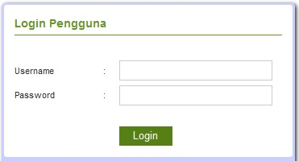
Gambar 5. 1: Tampilan Halaman Login
ada form ini digunakan untuk masuk pada halaman admin, sebelum masuk ke halaman admin, User dan Password yang diinput harus bernilai True atau benar. Jika User dan Password sudah benar klik tombol Login dan Halaman Utama / Halaman admin akan tampil tapi jika salah satu atau jika keduanya salah maka akan muncul pesan “Username atau Password yang anda masukkan salah”.

Tampilan Halaman Menu Utama
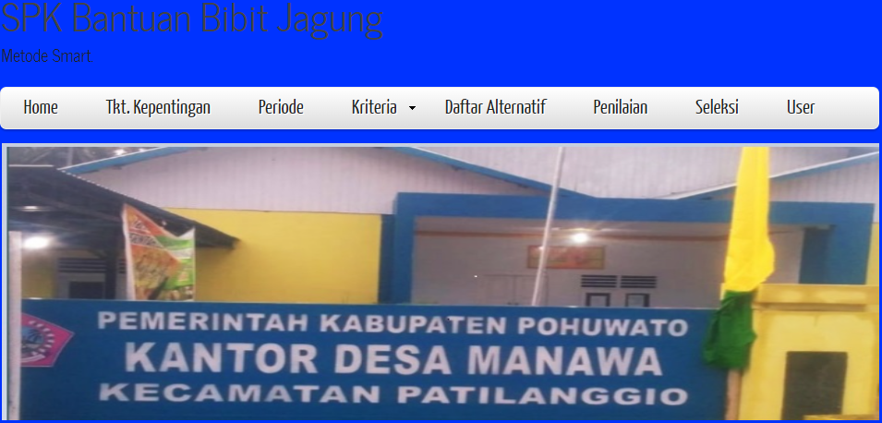
Gambar 5. 2: Halaman Menu Utama
Halaman Utama terdiri dari menu-menu utama yang terdapat pada Sistem Pendukung Keputusan Penerima Bantuan Bibit Jagung yaitu terdiri dari menu Beranda, menu Periode Seleksi, menu Kriteria, menu Data Alternatif, menu Penilaian, menu Seleksi, menu Grafik Nilai dan menu Pengguna.

Tampilan Menu

Tampilan Input Data Periode

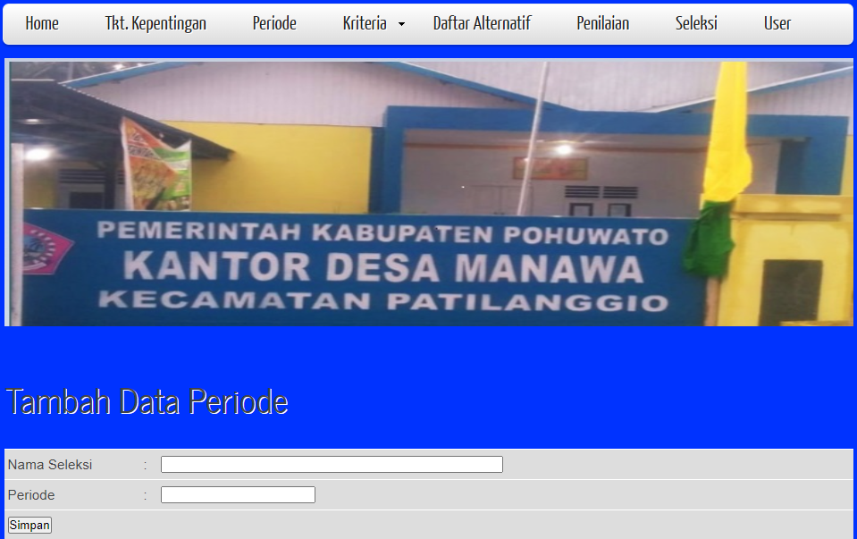Gambar 5. 3: Tampilan Input Data Periode
Pada tampilan input data periode digunakan untuk menginput periode seleksi yang dilakukan. Jika ingin menambah data periode, input Nama Seleksi dan Periode Seleksi selanjutnya tekan tombol Simpan.

Tampilan Input Data Kriteria

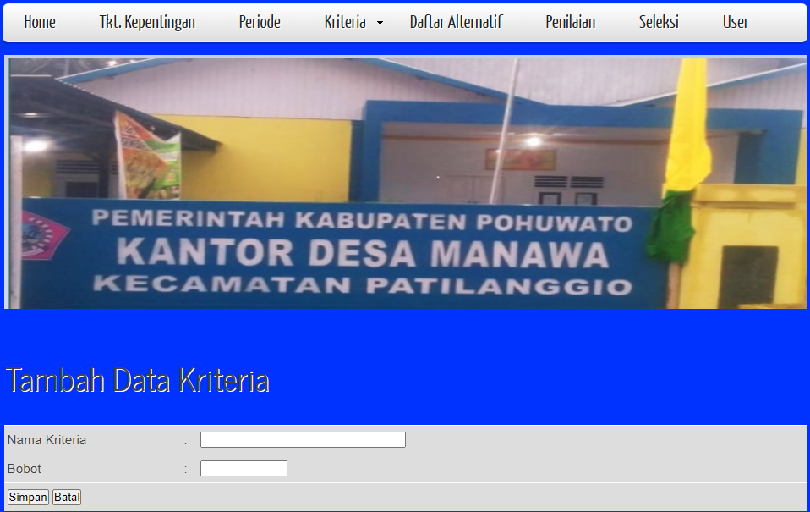
Gambar 5. 4: Tampilan Input Data Kriteria
Pada tampilan input Data ktriteria digunakan untuk menambah kriteria-kriteria yang digunakan dalam Menentukan Penerima Bantuan Bibit Jagung di Desa Manawa. Jika ingin menambah Kriteria, Input Nama Kriteria dan bobot selanjutnya tekan tombol simpan.

Tampilan Input Data Sub Kriteria

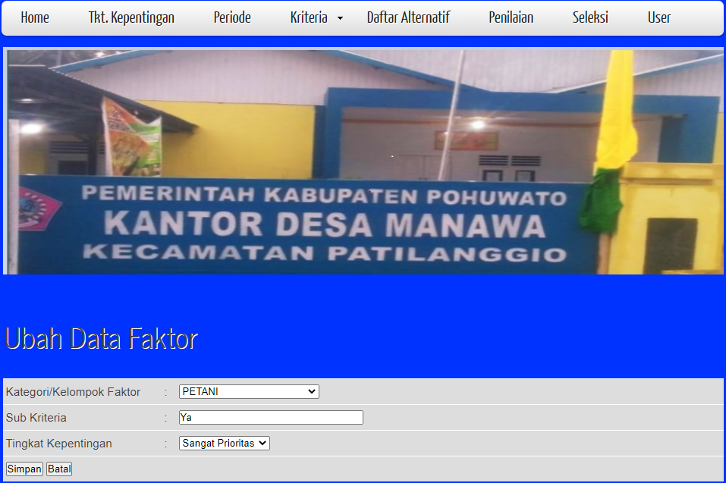
Gambar 5. 5: Tampilan Input Data Sub Kriteria
Pada tampilan Data sub kriteria ini digunakan untuk menginput Sub kriteria dan menentukan tingkat kepentingan dari sub kriteria. Jika ingin menambah sub kriteria tentukan terlebih dahulu kriteria yang ingin ditentukan sub kriterianya setelah itu input sub kriteria lalu pilih tingkat kepentingan selanjutnya klik tombol simpan.

Tampilan Input Data Alternatif

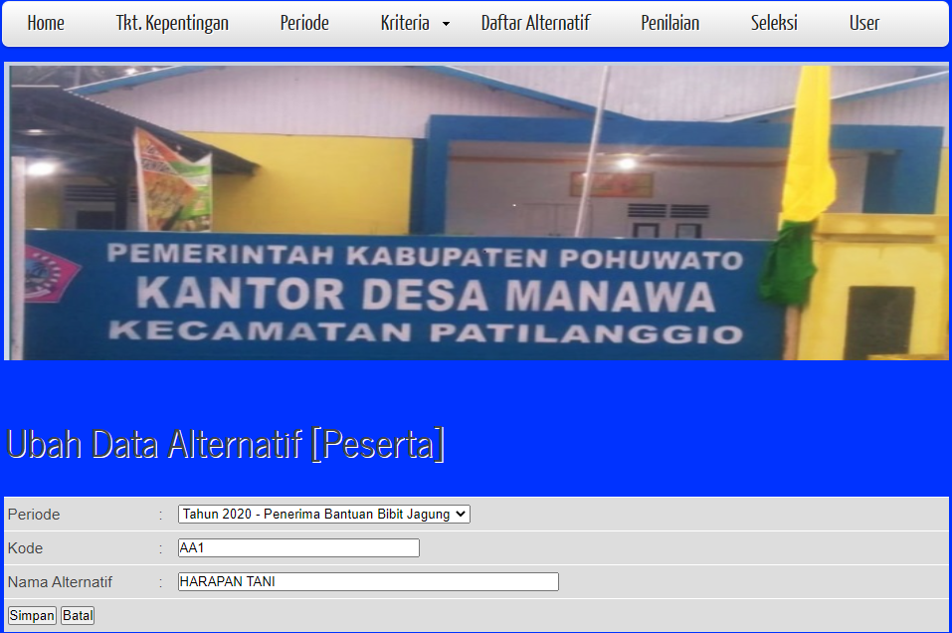
Gambar 5. 6: Tampilan Input Data Alternatif
Pada tampilan Input Data Alternatif digunakan untuk menginput Data Calon Anggota . Jika ingin menambah Data masukkan Kode dan nama alternatif selanjutnya klik tombol Simpan, dan data kepala keluargapun akan tersimpan di daftar alternatif.

Tampilan Input Data Penilaian

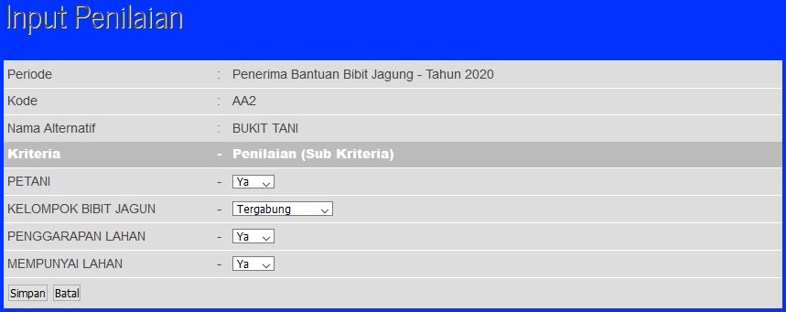
Gambar 5. 7: Tampilan Input Data Penilaian
Pada tampilan Input Data Penilaian ini digunakan untuk menginput nilai-nilai alternatif dilihat dari sub kriteria dari kriteria-kriteria yang sudah ditentukan. Sub kriteria yang dipilih merupakan penilaian yang diberikan untuk setiap Kepala Desa Manawa. Jika ingin menambah penilaian klik tombol simpan dan data akan tersimpan pada Data Nilai (Penilaian)

Tampil Input Pengguna

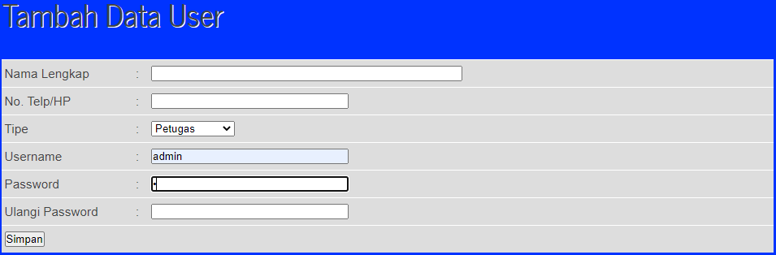
Gambar 5. 8: Gambar Tampilan Input Data Pengguna
Pada tampilan Tambah Data Pengguna ini digunakan untuk menginput Data Pengguna.Pengguna dapat mengakses data dan dapat mengoperasikan sistem. Jika ingin menambahkan data pengguna klik tombol simpan dan data pengguna akan tersimpan pada Data Pengguna (Pengguna)

Tampilan Proses

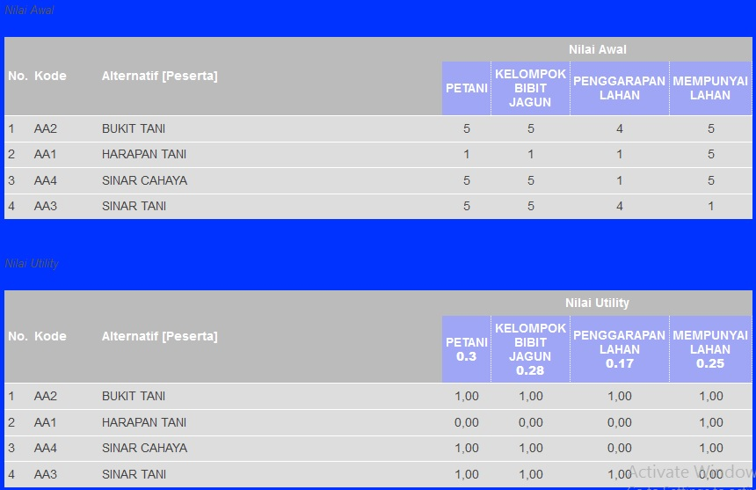

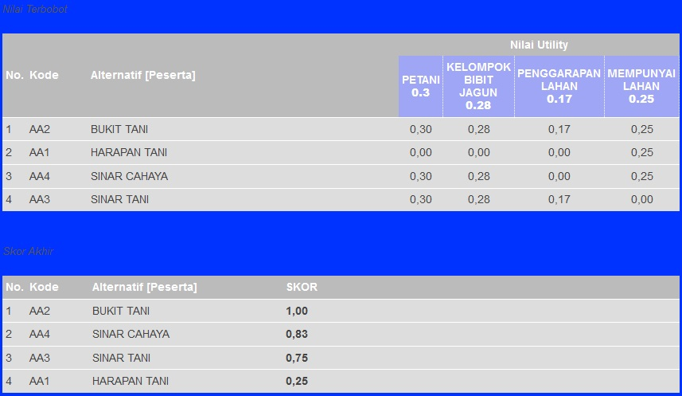
Gambar 5. 9: Tampilan Proses
Tampilan ini akan muncul jika semua data nilai sudah diisi untuk setiap alternatif. Jika ada salah satu alternatif ada nilainya bernilai 0 makan tampilan proses diatas belum bias ditampilkan, jadi kembali ke tampilan Input Data Nilai dan isi nilai yang masih bernilai 0.

Tampilan Laporan

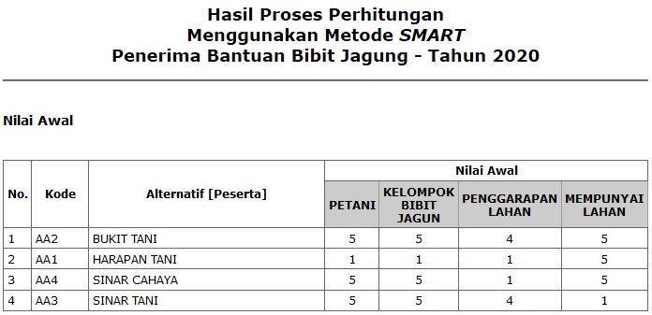

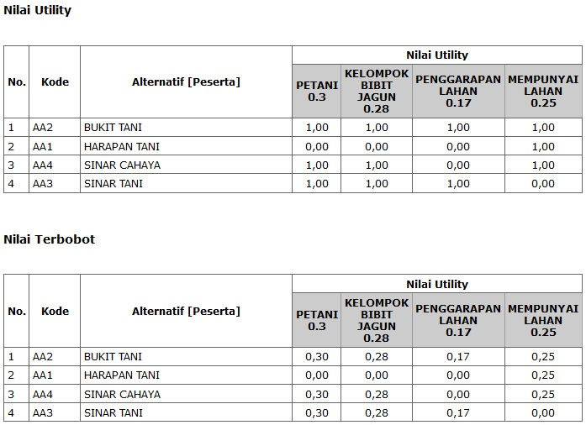
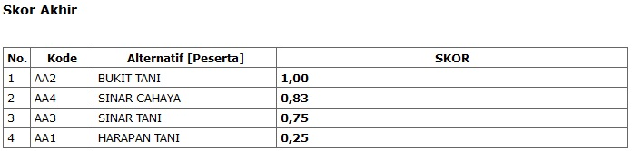
Gambar 5. 10: Tampilan Menu Laporan

BAB VI
KESIMPULAN DAN SARAN

6.1 Kesimpulan
Berdasarkan hasil penelitian yang telah dilakukan dan pembahasan yang telah di uraikan sebelumnya, maka dapat ditarik suatu kesimpulan bahwa :
- Dapat diketahui cara merancang / merekayasa sistem pendukung keputusan dalam menentukan Penerima Bantuan Bibit Jagung.
- Sistem pendukung keputusan ini dapat di implementasikan untuk Penentuan penerima bantuan bibit jagung. Hal ini dapat dibuktikan dengan hasil pengujian yang dilakukan dengan metode White Box Testing dan Bases Path Testing yang menghasilkan nilai V(G) = 9 CC.

6.2 Saran
Penulis ingin menyampaikan beberapa saran atau masukan bagi siapapun yang ingin mengembangkan atau menyempurnakan dari Sistem ini adalah sebagai berikut :
- Mengembangkan sistem ini dengan menambahkan metode lain untuk menyelesaikan permasalahan dengan secara terperinci.
- Mengembangkan sistem ini secara online sehingga para pengambil keputusan bisa melihat hasil dari sistem ini dimanapun dia berad
DAFTAR PUSTAKA

[1] Hidayatus Subyan, “Implementasi Metode Smart Pada Sistem Pendukung Keputusan Penerima Beasiswa Sekolah, “IEEE : Journal Penelitian dan Pengabdian Kepada Masyarakat UNSIQ, Vol.7 No.1, 78-83

[2] F.A.Ahda and S.Bahri, “Sistem Pendukung Keputusan Pemberian Beasiswa Untuk Siswa Kurang Mampu Di SMK Muhammadiyah 1 Kepanjen Menggunakan Metode Fuzzy Tsukamoto, “IEEE : Journal Spirit, Vol.9, No.2, ISSN.2085-3092, November 2017.

[3] Kementerian Pertanian Direktorat Jenderal Tanaman Pangan, “Petunjuk Pelaksanaan Bantuan Benih Padi dan Jagung Tahun Anggaran 2020, “Jakarta: Direktorat Jenderal Tanaman Pangan, 2020.

[4] Tata Sutabri, Analisis Sistem Informasi, Andi Yogyakarta, 2012.

[5] saktianada, “Kelebihan dan kekurangan Sistem Pendukung Keputusan Menurut Para Ahli. “http://blogspot.com kelebihan dan kekurangan sistem pendukung keputusan”.

[6] Cahyadsn, “Simple Multi Attribute Rating Technique (SMART),” 2018. [Online]. Available : https://cahyadsn.phpindonesia.id/extra/smart.php.

[7] A.S, R., & Shalahuddin, M., “Rekayasa Perangkat Lunak Terstruktur dan Berorientasi Objek, “Bandung: Informatika, 2018.

[8] Arief, M. R., “Pemrograman Web Dinamis Menggunakan PHP dan MYSQL,” Andi Publisher, 2012.

[9] Adeli, “Dreamweaver CS6 Untuk Orang Awam,” palembang: Maxicon, 2013.

[10] Heri Hidayat, Menjadi Master Photoshop Untuk Pemula Dari Nol Hingga Mahir, Jakarta: Dunia Komputer, 2011

[11] Dadang Haryanto, Dhea Argadila,”Sistem Informasi Pengarsipan Data Konsumen di PT.Dinasti Pertiwi Perumahan Dewasari”,Jurnal Teknik Informatika, Vol. 7, No. 1, 2019.

[21] Tim Dosen Universitas Ichsan Gorontalo, “Pedoman Penelitian Ilmu Komputer”, 2021

Lampiran 1 : Gambaran Umum Desa Manawa
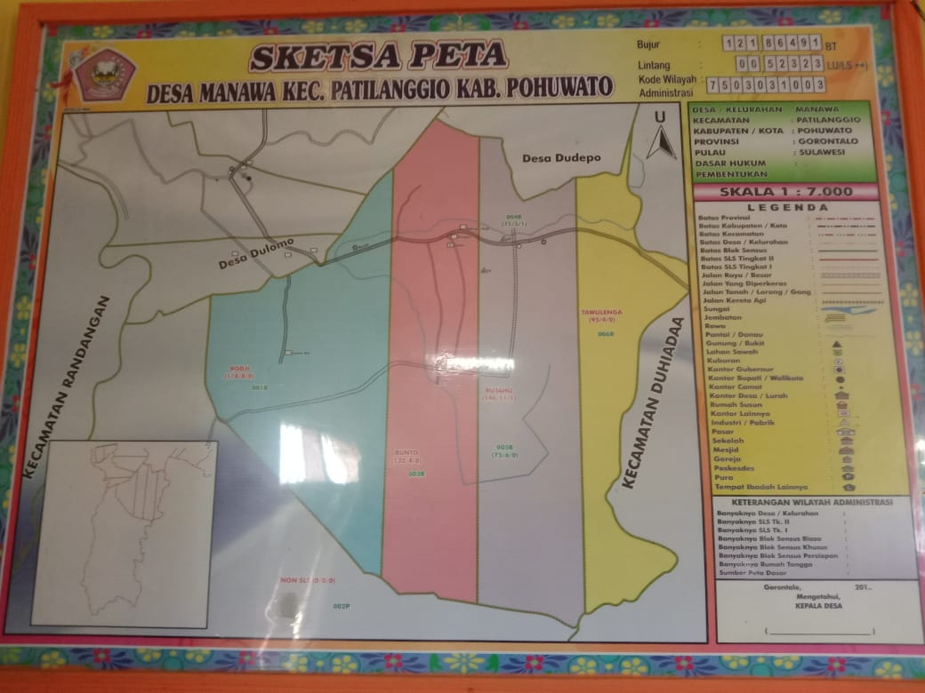
Gambar : Peta Desa Manawa

Desa Manawa merupakan salah satuh desa dari 6 desa yang ada di Kecamatan Patilanggio, Desa Manawa memiliki luas Rata-rata 4000 X 7000 KM di mana dari Utara - Selata memiliki luas 7000 KM sedangkan Timur - Barat memiliki luas 4000 KM jadi luas keseluruhan 28000 KM. Secara Adminisratif dapat dilihat dalam Peta Desa Manawa memiliki 4 Dusun sesuai dengan warna-warna yang ditetapkan berbeda dimana yaitu Dusu Taulenga berwarna Kuning, Dusun Butahu berwarna Ungu, Dusun Bunto berwarna Merah Muda Dan Dusun Rodji berwarna Biru. Secara Geografis Desa Manawa berbatasan dengan
    - Sebelah Utara berbatasan dengan Desa Sukamakmur
    - Sebelah Timur berbatasan dengan Sungai atau sering masyarakat sekitar dengan sebutan Koala disebelahnya ada Desa Mekar jaya/ Desa Mootilango
    - Sebelah selatan berbatasan dengan Teluk Tomini (laut) untuk skarang sudah menjadi Tempat Budidaya Ikan (Empag)
    - Sebelah Barat berbatasan dengan Sungai Randangan dan di sebelah sungai ada Desa Limbodu.
Secara Tofografi Desa Manawa memiliki Lahan yang Datar juga memilki ketinggian diatas permukaan laut rata-rata 3 M, wilayah lainya merupakan area Pekebunan rakyat dan area Pertambakan Ikan Badeng dan Udang.

Lampiran 2 : Struktur Organisasi Kantor Desa Manawa
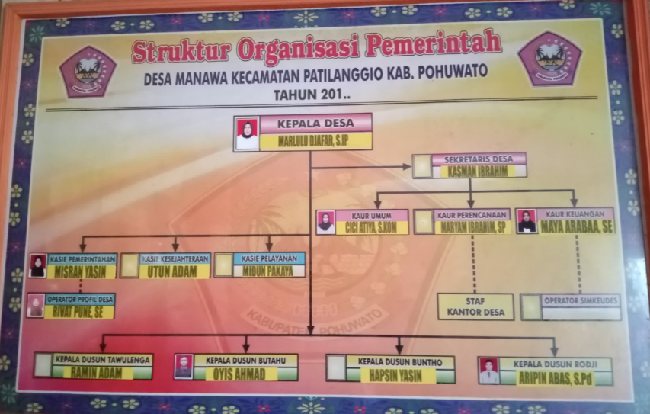
:
Lampiran 3 : Nama – Nama Kepala Desa Manawa Yang Pernah Menjabat
- Harun Usman Lukum
- Faruk Sanad
- Alfred Naue
- Ardin Suleman, SE
- Mursid Alim, S.Sos
- Ishak Van Gobel
- Marlulu Djafar, S.Ip

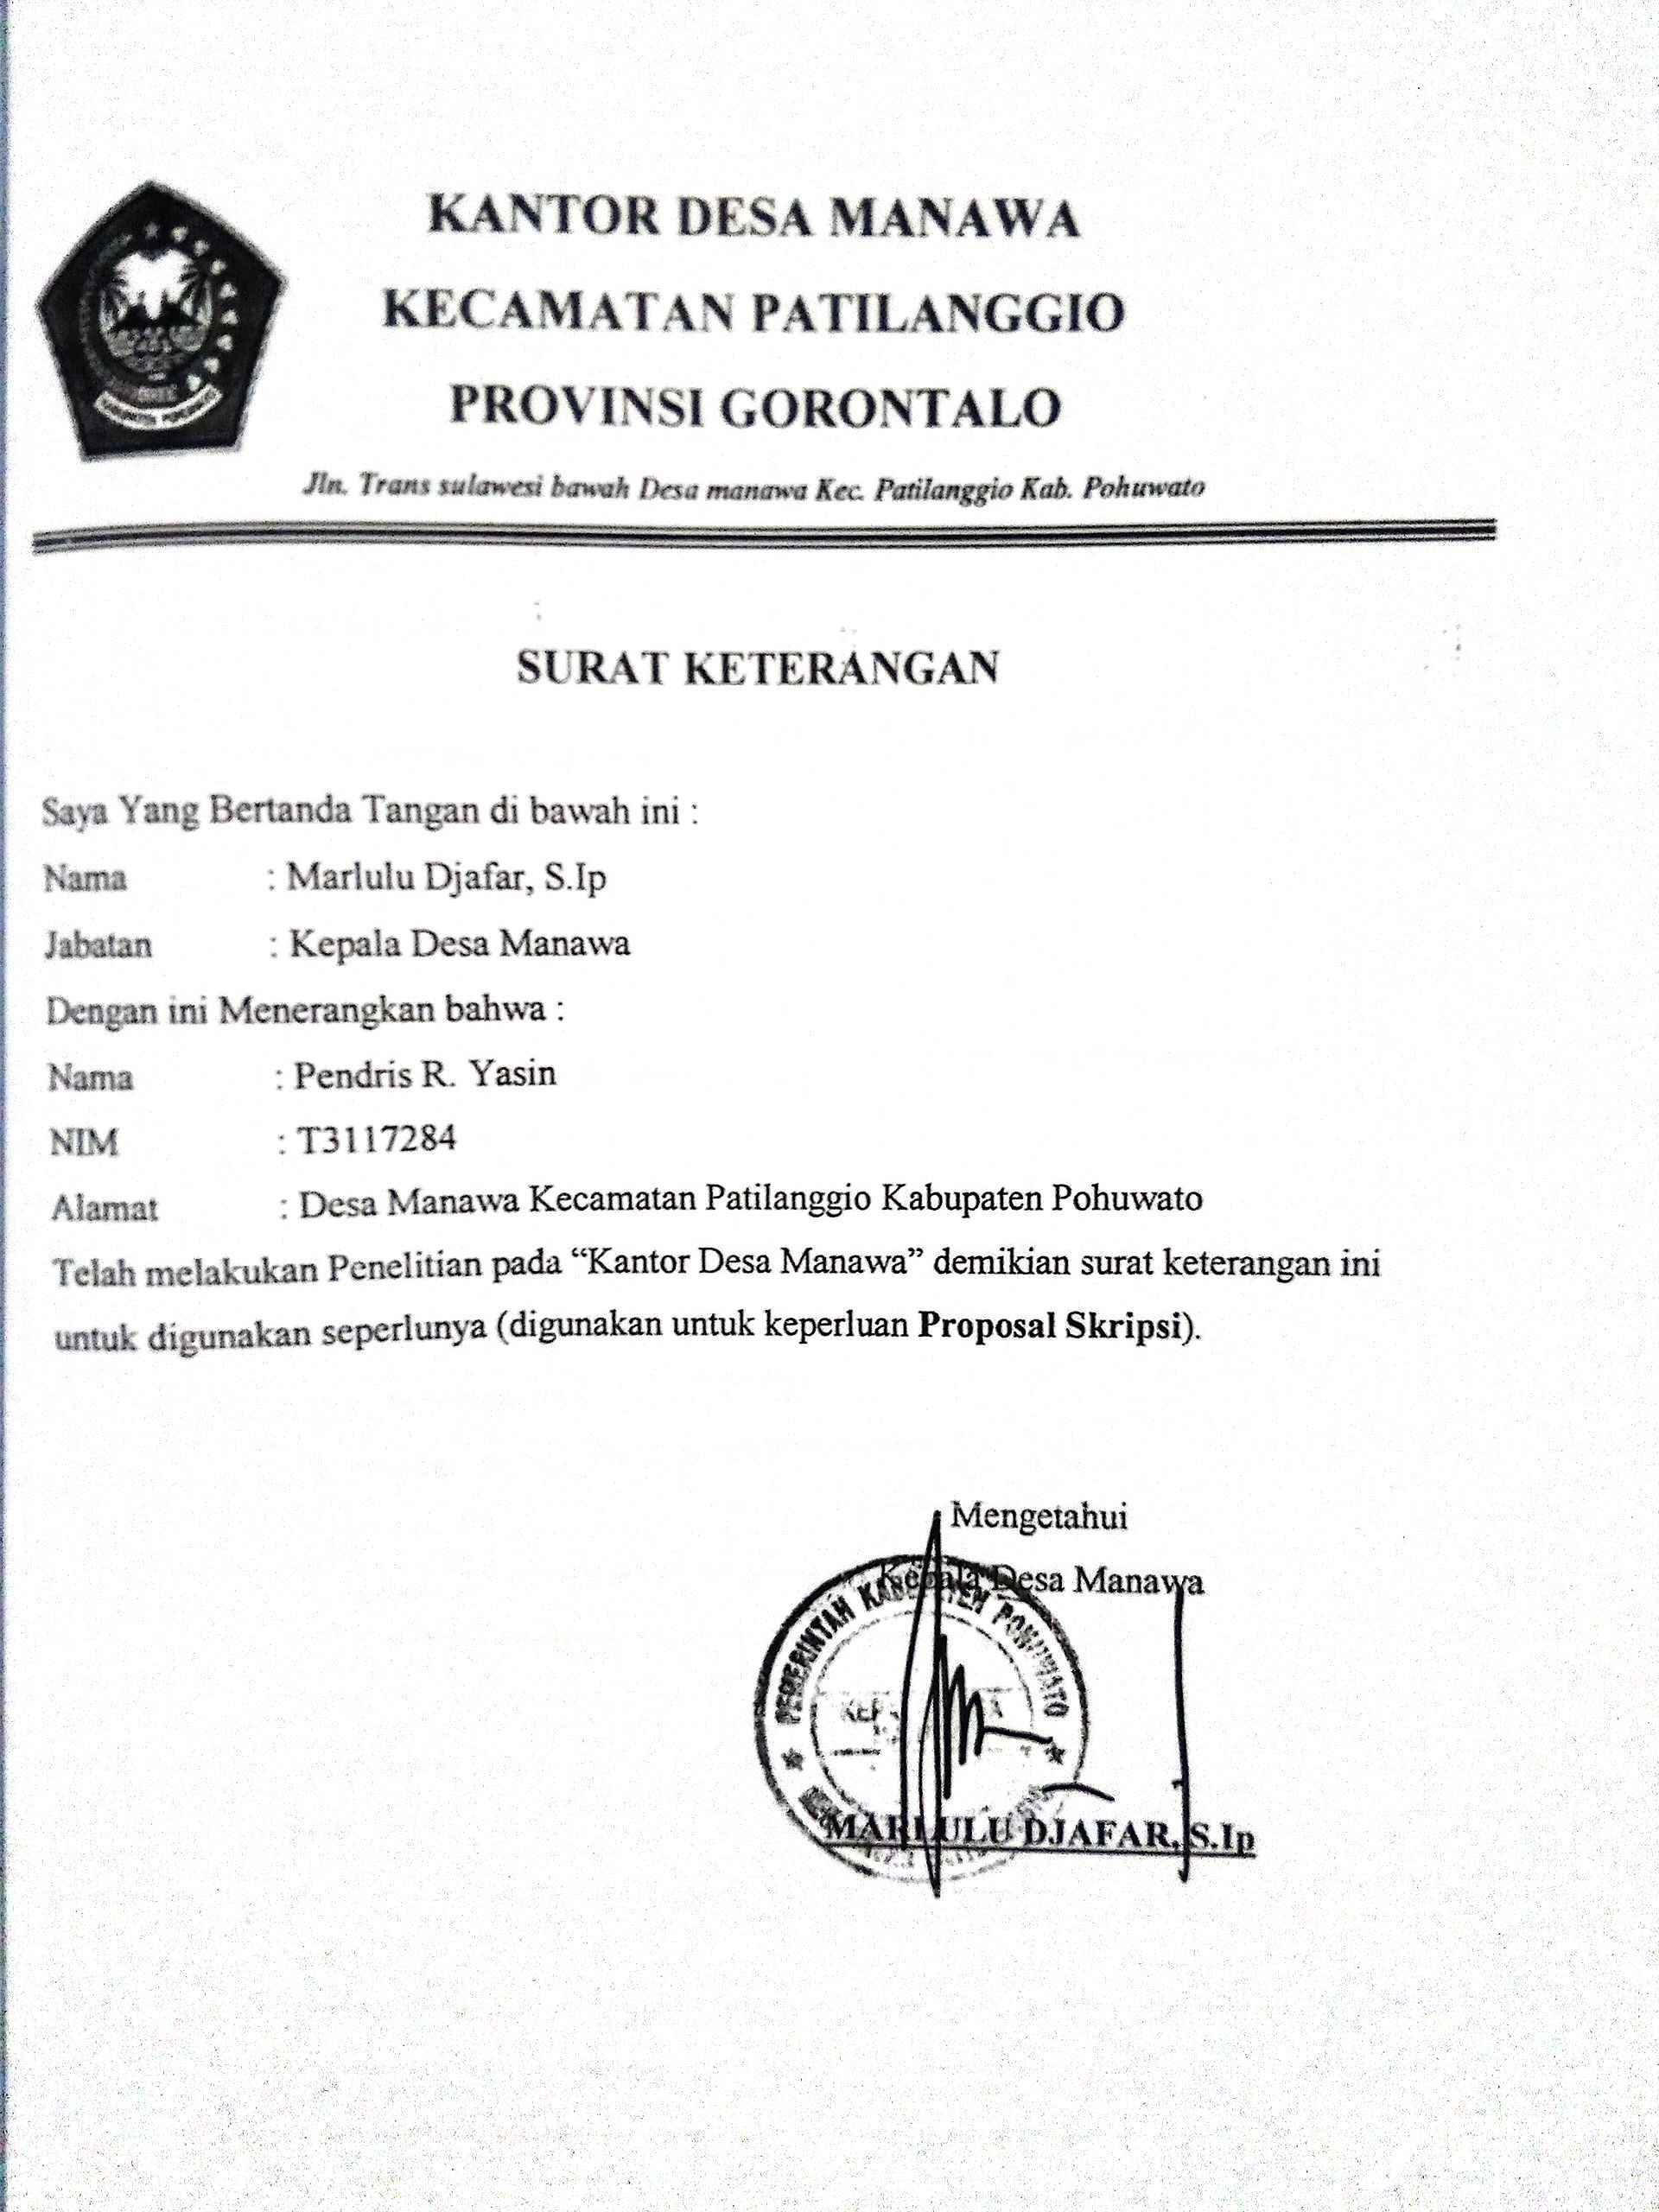

Lampiran 4 : Listing Program
- Index
<?php
include "./config/library.php";
include "./config/koneksi.php";
opendb();
$ses_nama_pengguna=antiinjec(@$_SESSION['ses_nama_pengguna']);

if($ses_nama_pengguna=="")
{
?>
<script language="JavaScript">document.location='login.php'</script>
<?php
} else {
$queryadm="SELECT * FROM sm_pengguna WHERE username='$ses_nama_pengguna'";
$hasiladm=querydb($queryadm);
$dataadm=mysql_fetch_array($hasiladm);

if($dataadm['tipe']==1) { $tipe_pengguna="Administrator"; }
elseif($dataadm['tipe']==2) { $tipe_pengguna="Petugas"; }
?>
<!DOCTYPE HTML>
<html>

<head>
<title>SPK_Penerima Bantuan Bibit jagung Pada Desa Manawa dengan Menggunakan Metode Smart</title>
<meta name="description" content="website description" />
<meta name="keywords" content="website keywords, website keywords" />
<meta http-equiv="content-type" content="text/html; charset=UTF-8" />
<link rel="stylesheet" type="text/css" href="css/style.css" />
<!-- modernizr enables HTML5 elements and feature detects -->
<script type="text/javascript" src="js/modernizr-1.5.min.js"></script>
</head>

<body>
<div id="main">
<header>
<div id="logo">
<div id="logo_text">
<!-- class="logo_colour", allows you to change the colour of the text -->
<h1><a href="index.html">SPK Bantuan Bibit Jagung<span class="logo_colour"></span></a></h1>
<h2>Metode Smart.</h2>
</div>
</div>
<nav>
<ul class="sf-menu" id="nav">
<li><a href="./">Beranda</a></li>
<li><a href="?page=periode">Periode</a></li>
<li><a href="#">Kriteria</a>
<ul>
<li><a href="?page=kriteria">Data Kriteria</a></li>
<li><a href="?page=kriteria-sub">Data Sub Kriteria</a></li>
<li><a href="?page=kepentingan">Tkt. Kepentingan</a></li>
</ul>
</li>
<li><a href="?page=alternatif">Daftar Alternatif</a></li>
<li><a href="?page=nilai">Penilaian</a></li>
<li><a href="?page=seleksi">Seleksi</a></li>
<li><a href="?page=grafik">Grafik Nilai</a></li>
<?php if($dataadm['tipe']==1) { ?>
<li><a href="?page=pengguna">Pengguna</a></li>
<?php } ?>
</ul>
</nav>
</header>
<div id="site_content">
<div class="gallery">
<ul class="images">
<li class="show"><img width="950" height="300" src="images/1.jpg" alt="photo_one" /></li>
<li><img width="950" height="300" src="images/2.jpg" alt="photo_two" /></li>
<li><img width="950" height="300" src="images/3.jpg" alt="photo_three" /></li>
</ul>
</div>
<div id="sidebar_container"></div>
<div class="content">
<?php
$page=@$_GET['page'];
if($page=="alternatif"){ include "data_alternatif.php"; }
elseif($page=="alternatif-input"){ include "input_alternatif.php"; }
elseif($page=="kriteria"){ include "data_kriteria.php"; }
elseif($page=="kriteria-input"){ include "input_kriteria.php"; }
elseif($page=="kriteria-sub"){ include "data_kriteria_sub.php"; }
elseif($page=="kriteria-sub-input"){ include "input_kriteria_sub.php"; }
elseif($page=="kepentingan"){ include "data_kepentingan.php"; }
elseif($page=="kepentingan-input"){ include "input_kepentingan.php"; }
elseif($page=="nilai"){ include "data_nilai.php"; }
elseif($page=="nilai-input"){ include "input_nilai.php"; }

elseif($page=="kategori"){ include "data_kategori.php"; }
elseif($page=="kategori-input"){ include "input_kategori.php"; }
elseif($page=="periode"){ include "data_periode.php"; }
elseif($page=="periode-input"){ include "input_periode.php"; }
elseif($page=="pengguna" && $dataadm['tipe']==1){ include "data_pengguna.php"; }
elseif($page=="pengguna-input" && $dataadm['tipe']==1){ include "input_pengguna.php"; }
elseif($page=="faktor-periode"){ include "data_faktor_periode.php"; }
elseif($page=="faktor-periode-input"){ include "input_faktor_periode.php"; }
elseif($page=="seleksi"){ include "data_seleksi.php"; }
elseif($page=="ubah-password"){ include "set_password.php"; }
elseif($page=="grafik"){ include "grafik_1_container.php"; }
else { include "home.php"; }
?>
</div>
</div>
<footer>
<p>Copyright &copy; Pendris R. Yasin| <a href="http://www.css3templates.co.uk">Fakultas Ilmu Komputer</a></p>
</footer>
</div>
<p>&nbsp;</p>
<!-- javascript at the bottom for fast page loading -->
<script type="text/javascript" src="js/jquery.js"></script>
<script type="text/javascript" src="js/jquery.easing-sooper.js"></script>
<script type="text/javascript" src="js/jquery.sooperfish.js"></script>
<script type="text/javascript" src="js/image_fade.js"></script>
<script type="text/javascript">
$(document).ready(function() {
$('ul.sf-menu').sooperfish();
});
</script>
</body>
</html>
<?php } closedb(); ?>

- Config
- Koneksi
<?php
//koneksi.php
$dbhost="localhost";
$dbname="db_bibit";
$dbuser="root";
$dbpassword="";

function opendb()
{
global $dbhost, $dbuser, $dbpassword, $dbname, $dbconnection;
$dbconnection=mysql_connect($dbhost, $dbuser, $dbpassword)
or die ("gagal membuka database");
$dbselect=mysql_select_db($dbname);
}

function closedb()
{
global $dbconnection;
mysql_close($dbconnection);
}

function querydb($query)
{
$result=mysql_query($query) or die ("gagal melakukan Query=$query");
return $result;
}
?>
- Library
<?php
session_start();
date_default_timezone_set('Asia/Jakarta');

$seminggu = array("Minggu","Senin","Selasa","Rabu","Kamis","Jumat","Sabtu");
$hari = date("w");
$hari_ini = $seminggu[$hari];
$set_judul = "SPK Bantuan Bibit Jagung Pada Desa Manawa Menggunakan Metode Smart";
$set_judul_sub = "Seleksi Penerima Bantuan Rumah Layak Huni - Metode SMART";
$set_alternatif = "Peserta";

$tgl_sekarang = date("Ymd");
$tgl_skrg = date("d");
$bln_sekarang = date("m");
$thn_sekarang = date("Y");
$jam_sekarang = date("H:i:s");

$nama_bln=array(1=> "Januari", "Februari", "Maret", "April", "Mei",
"Juni", "Juli", "Agustus", "September",
"Oktober", "November", "Desember");

function antiinjec($data){
$filter_sql = mysql_real_escape_string(stripslashes(strip_tags(htmlspecialchars($data,ENT_QUOTES))));
return $filter_sql;
}
$tgl_full=date("Y-m-d H:i:s");

$sesinf_adminid=1;

function tgl_waktu($data){
$tgl_waktu=date("d-m-Y H:i:s", strtotime($data));
return $tgl_waktu;
}
?>

- Data Kriteria
<h1>Data Kriteria</h1>
<?php
$txtcari=antiinjec(@$_REQUEST['cari']);
$d_jml=mysql_fetch_array(querydb("SELECT SUM(bobot) FROM sm_kriteria"));
$h_krt=querydb("UPDATE sm_kriteria SET bobot_normal=bobot/$d_jml[0]");
?>
<form method="post" action="" enctype="multipart/form-data">
<table width="100%" border="0" cellspacing="0" cellpadding="0">
<tr>
<td width="9%">Pencarian :</td>
<td width="14%"><input name="cari" type="text" size="30" value="<?php echo"$txtcari"; ?>"/></td>
<td width="77%"><input name="" type="submit" value="Cari" class="cari"/></td>
</tr>
</table>
</form>
<table width="100%" border="0" cellpadding="0" cellspacing="0" >
<tr>
<th width="2%">No.</th>
<th width="47%">Kriteria</th>
<th width="10%">Bobot</th>
<th width="36%">Normalisasi</th>
<script type="text/javascript">
function konTambah() {
window.location = "?page=kriteria-input&act=tambah";
}
</script>
<th width="5%" align="center"><input type='button' class='tombol' value='Tambah' onclick="konTambah()"></th>
</tr>
<?php
$halaman=@$_GET['halaman'];
$perhalaman=10;
$kat=@$_GET['kat'];
$query_part ="SELECT id_kriteria FROM sm_kriteria WHERE kriteria LIKE '%$txtcari%'";
$hasil_part = querydb($query_part);
$jmlhalaman_part = ceil(mysql_num_rows($hasil_part)/$perhalaman);

if (!isset($halaman))
{
$halaman=0;
}
else
{
$halaman=$halaman-1;
}
$halamannya = $halaman * $perhalaman;

$nomor=$halamannya;
$query="SELECT a.id_kriteria, a.kriteria, a.skala, a.bobot, a.bobot_normal FROM sm_kriteria as a
WHERE a.kriteria LIKE '%$txtcari%' ORDER BY a.id_kriteria ASC LIMIT $halamannya, $perhalaman" ;
$hquery=querydb($query);
while ($dataquery=mysql_fetch_array($hquery)) {
$nomor=$nomor+1;
?>
<script type="text/javascript">
function konfirmasi<?php echo $dataquery[0]; ?>() {
var answer = confirm("Anda yakin akan menghapus data ini?")
if (answer){
window.location = "aksi_kriteria.php?act=hapus&id=<?php echo"$dataquery[0]"; ?>";
}
}
</script>
<tr>
<td><?php echo"$nomor"; ?></td>
<td><?php echo"$dataquery[kriteria]"; ?></td>
<td><?php echo"$dataquery[bobot]"; ?></td>
<td><?php echo"$dataquery[bobot_normal]"; ?></td>
<td align="center">
<a href="?page=kriteria-input&act=edit&id=<?php echo"$dataquery[0]"; ?>">
<img src="./images/bt_edit.png" height="20" alt="Ubah" border="0" title="Ubah Data" style="float:left;"/>
</a>
<img src="./images/bt_del.png" height="20" alt="Hapus" border="0" title="Hapus Data" style="float:left; cursor:pointer;" onclick="konfirmasi<?php echo $dataquery[0]; ?>()"/>
</td>
</tr>
<?php
}
?>
</table>
<div style="margin-top:20px; padding-top:10px; clear:both; line-height:normal;">
<div style="padding:3px 4px; margin:1px; background-color:#6b9429; color:#FFCEE7; float:left;">Halaman :</div>
<?php
for($j=1;$j<($jmlhalaman_part+1);$j++)
{
?>
<div style="padding:3px 4px; margin:1px; <?php if (($halaman+1)==$j) { echo"background-color:#858ffb"; } else { echo"background-color:#6b9429"; } ?>; color:#FFFFFF; float:left;">
<a href="?page=kriteria&halaman=<?php echo"$j"; ?><?php if($txtcari<>"") { echo"&cari=$txtcari"; } ?>" title="Halaman : <?php echo"$j"; ?>" style="text-decoration:none; color:#FFF;"><?php echo"$j"; ?></a>
</div>
<?php }
?>
</div>

- Data Seleksi
<h1>Seleksi Alternatif (Perhitungan SMART)</h1>
<?php
$periode=(int)antiinjec(@$_POST['periode']);
$stat=antiinjec(@$_REQUEST['stat']);
?>
<form method="post" action="#" enctype="multipart/form-data">
<table width="100%" border="0" cellspacing="0" cellpadding="0">
<tr>
<td width="9%">Periode :</td>
<td width="14%">
<select name="periode">
<?php
$q_per="SELECT id_periode, seleksi, periode FROM sm_periode ORDER BY periode DESC, seleksi DESC";
$h_per=querydb($q_per);
while($d_per=mysql_fetch_array($h_per)){
?>
<option value="<?php echo $d_per['id_periode']; ?>" <?php if($d_per['id_periode']==$periode) { echo "selected"; } ?>>
<?php echo $d_per['periode']." - ".$d_per['seleksi']; ?>
</option>
<?php
}
?>
</select>
</td>
<td width="77%"><input name="proses_hitung" type="submit" value="Proses Hitung" class="cari"/></td>
</tr>
</table>
</form>
<?php
if($periode>0 && @$_POST['proses_hitung']) {
//xxxxxxxxxxxxxxxxxxxxxxxxxxxxxxxxxxxxxxxxxxxxxxxxxxxxxxxxxxxxxxxxxxxxxxxxxxxxxxxxxxxxxxxxxxxxxxxxxxxxxxxxxxxxxxxxxxx
//AWAL METODE SMART
$q_alter="SELECT id_alternatif FROM sm_alternatif WHERE id_periode=$periode ORDER BY kode" ;
$h_alter=querydb($q_alter);
while ($d_alter=mysql_fetch_assoc($h_alter)) {

$hasil=0;

$q_kriteria="SELECT id_kriteria, kriteria, bobot_normal FROM sm_kriteria ORDER BY id_kriteria ASC";
$h_kriteria=querydb($q_kriteria);
while ($d_kriteria=mysql_fetch_assoc($h_kriteria)) {

$nilai_utility=0;
$nilai_terbobot=0;

$q_nilai="SELECT id_nilai_kriteria, nilai FROM sm_nilai_kriteria
WHERE id_kriteria=".$d_kriteria['id_kriteria']." AND id_alternatif=".$d_alter['id_alternatif']."";
$h_nilai=querydb($q_nilai);
$d_nilai=mysql_fetch_assoc($h_nilai);

$n_max=mysql_fetch_row(querydb("SELECT MAX(nilai) FROM sm_nilai_kriteria
WHERE id_kriteria=".$d_kriteria['id_kriteria'].""));
$n_min=mysql_fetch_row(querydb("SELECT MIN(nilai) FROM sm_nilai_kriteria
WHERE id_kriteria=".$d_kriteria['id_kriteria'].""));

$nilai_utility=(($n_max[0]-$n_min[0])==0) ? 0 : ($d_nilai['nilai']-$n_min[0])/($n_max[0]-$n_min[0]);
$nilai_terbobot=$nilai_utility*$d_kriteria['bobot_normal'];
$hasil+=$nilai_terbobot;

//Simpan Hasil
$q_cek="SELECT COUNT(*) FROM sm_nilai_utility WHERE id_nilai_kriteria=".$d_nilai['id_nilai_kriteria']."";
$h_cek=querydb($q_cek);

$d_cek=mysql_fetch_row($h_cek);
if($d_cek[0]==0) {
$q_simpan="INSERT INTO sm_nilai_utility (id_nilai_kriteria, nilai, nilai_terbobot)
VALUES ($d_nilai[id_nilai_kriteria], $nilai_utility, $nilai_terbobot)";
querydb($q_simpan);
} else {
$q_ubah="UPDATE sm_nilai_utility SET nilai=$nilai_utility, nilai_terbobot=$nilai_terbobot
WHERE id_nilai_kriteria=".$d_nilai['id_nilai_kriteria']."";
querydb($q_ubah);
}

}

//Simpan hasil akhir nya
$q_cek2="SELECT COUNT(*) FROM sm_hasil WHERE id_alternatif=".$d_alter['id_alternatif']."";
$h_cek2=querydb($q_cek2);
$d_cek2=mysql_fetch_row($h_cek2);
if($d_cek2[0]==0) {
$q_simpan="INSERT INTO sm_hasil (id_alternatif, nilai)
VALUES ($d_alter[id_alternatif], $hasil)";
querydb($q_simpan);
} else {
$q_ubah="UPDATE sm_hasil SET nilai=$hasil
WHERE id_alternatif=".$d_alter['id_alternatif']."";
querydb($q_ubah);
}
//AKHIR METODE SMART
//xxxxxxxxxxxxxxxxxxxxxxxxxxxxxxxxxxxxxxxxxxxxxxxxxxxxxxxxxxxxxxxxxxxxxxxxxxxxxxxxxxxxxxxxxxxxxxxxxxxxxxxxxxxxxxxxxxx
}

if(@$_POST['proses_hitung'] || @$_POST['proses_lihat']) {
$qka="SELECT id_kriteria, kriteria, bobot_normal FROM sm_kriteria ORDER BY id_kriteria ASC";
$hk=querydb($qka);
$jmlkkolom=mysql_num_rows($hk);
?>
<style>
.test table { border:1px solid #000000; }
.test table tr td { border:1px dotted #333333; }
.test table tr th { border:1px dotted #333333; }
.okok { background-color:#4f5ac7; color:#09C; }
</style>
<br />
<h6>Nilai Awal</h6>
<table width="100%" border="0" cellspacing="0" cellpadding="4">
<tr>
<th width="24" rowspan="2" style="vertical-align:middle;">No.</th>
<th width="101" rowspan="2" style="vertical-align:middle;">Kode</th>
<th width="659" rowspan="2" style="vertical-align:middle;">Alternatif [<?php echo $set_alternatif; ?>]</th>
<th colspan="<?php echo $jmlkkolom; ?>"><div style="text-align:center;">Nilai Awal</div></th>
</tr>
<tr>
<?php
$hka=querydb($qka);
while($dka=mysql_fetch_array($hka)){
?>
<th style="background-color:#9ea6f5; border-right:1px dotted #FFF;"><div style="text-align:center;"><?php echo "$dka[kriteria]"; ?></div></th>
<?php } ?>
</tr>

<?php
$no=0;

$queryX="SELECT id_alternatif, kode, alternatif FROM sm_alternatif WHERE id_periode=$periode ORDER BY alternatif ASC";
$hqueryX=querydb($queryX);
while ($dquX=mysql_fetch_array($hqueryX)){
$no=$no+1;
?>
<tr>
<td><?php echo"$no"; ?></td>
<td><?php echo"$dquX[kode]"; ?></td>
<td><?php echo"$dquX[alternatif]"; ?></td>
<?php
$urut=0;
$hk2=querydb($qka);
while($dk2=mysql_fetch_array($hk2)){
$urut=$urut+1;

//Ambil Nilai yang sudah disimpan (lalu tampilkan)
$qn="SELECT nilai FROM sm_nilai_kriteria WHERE id_alternatif='$dquX[id_alternatif]' AND id_kriteria='$dk2[id_kriteria]'";
$hn=querydb($qn);
$dn=mysql_fetch_assoc($hn);
?>
<td>
<div style="text-align:center;">
<?php echo number_format($dn['nilai'],0,',','.'); ?>
</div>
</td>
<?php } ?>
</tr>
<?php } ?>
</table>

<br />
<h6>Nilai Utility</h6>
<table width="100%" border="0" cellspacing="0" cellpadding="4">
<tr>
<th width="24" rowspan="2" style="vertical-align:middle;">No.</th>
<th width="101" rowspan="2" style="vertical-align:middle;">Kode</th>
<th width="659" rowspan="2" style="vertical-align:middle;">Alternatif [<?php echo $set_alternatif; ?>]</th>
<th colspan="<?php echo $jmlkkolom; ?>"><div style="text-align:center;">Nilai Utility</div></th>
</tr>
<tr>
<?php
$hka=querydb($qka);
while($dka=mysql_fetch_array($hka)){
?>

<th style="background-color:#9ea6f5; border-right:1px dotted #FFF;"><div style="text-align:center;"><?php echo $dka['kriteria']."<br><b>".$dka['bobot_normal']."</b>"; ?></div></th>
<?php } ?>
</tr>

<?php
$no=0;

$queryX="SELECT id_alternatif, kode, alternatif FROM sm_alternatif WHERE id_periode=$periode ORDER BY alternatif ASC";
$hqueryX=querydb($queryX);
while ($dquX=mysql_fetch_array($hqueryX)){
$no=$no+1;
?>
<tr>
<td><?php echo"$no"; ?></td>
<td><?php echo"$dquX[kode]"; ?></td>
<td><?php echo"$dquX[alternatif]"; ?></td>
<?php
$urut=0;
$hk2=querydb($qka);
while($dk2=mysql_fetch_array($hk2)){
$urut=$urut+1;

//Ambil Nilai Perhitungan
$qn="SELECT id_nilai_kriteria FROM sm_nilai_kriteria WHERE id_alternatif='$dquX[id_alternatif]' AND id_kriteria='$dk2[id_kriteria]'";
$hn=querydb($qn);
$dn=mysql_fetch_row($hn);

$qn_2="SELECT nilai FROM sm_nilai_utility WHERE id_nilai_kriteria=".(int)$dn[0]."";
$hn_2=querydb($qn_2);
$dn_2=mysql_fetch_assoc($hn_2);
?>
<td>
<div style="text-align:center;">
<?php echo number_format($dn_2['nilai'],2,',','.'); ?>
</div>
</td>
<?php } ?>
</tr>
<?php } ?>
</table>

<br />
<h6>Nilai Terbobot</h6>
<table width="100%" border="0" cellspacing="0" cellpadding="4">
<tr>
<th width="24" rowspan="2" style="vertical-align:middle;">No.</th>
<th width="101" rowspan="2" style="vertical-align:middle;">Kode</th>
<th width="659" rowspan="2" style="vertical-align:middle;">Alternatif [<?php echo $set_alternatif; ?>]</th>
<th colspan="<?php echo $jmlkkolom; ?>"><div style="text-align:center;">Nilai Utility</div></th>
</tr>
<tr>
<?php
$hka=querydb($qka);
while($dka=mysql_fetch_array($hka)){
?>
<th style="background-color:#9ea6f5; border-right:1px dotted #FFF;"><div style="text-align:center;"><?php echo $dka['kriteria']."<br><b>".$dka['bobot_normal']."</b>"; ?></div></th>
<?php } ?>
</tr>

<?php
$no=0;

$queryX="SELECT id_alternatif, kode, alternatif FROM sm_alternatif WHERE id_periode=$periode ORDER BY alternatif ASC";
$hqueryX=querydb($queryX);
while ($dquX=mysql_fetch_array($hqueryX)){
$no=$no+1;
?>
<tr>
<td><?php echo"$no"; ?></td>
<td><?php echo"$dquX[kode]"; ?></td>
<td><?php echo"$dquX[alternatif]"; ?></td>
<?php
$urut=0;
$hk2=querydb($qka);
while($dk2=mysql_fetch_array($hk2)){
$urut=$urut+1;

//Ambil Nilai Perhitungan
$qn="SELECT id_nilai_kriteria FROM sm_nilai_kriteria WHERE id_alternatif='$dquX[id_alternatif]' AND id_kriteria='$dk2[id_kriteria]'";
$hn=querydb($qn);
$dn=mysql_fetch_row($hn);

$qn_2="SELECT nilai_terbobot FROM sm_nilai_utility WHERE id_nilai_kriteria=".(int)$dn[0]."";
$hn_2=querydb($qn_2);
$dn_2=mysql_fetch_assoc($hn_2);
?>
<td>
<div style="text-align:center;">
<?php echo number_format($dn_2['nilai_terbobot'],2,',','.'); ?>
</div>
</td>
<?php } ?>
</tr>
<?php } ?>
</table>

<br />
<h6>Skor Akhir</h6>
<table width="100%" border="0" cellspacing="0" cellpadding="4">
<tr>
<th width="24" style="vertical-align:middle;">No.</th>
<th width="101" style="vertical-align:middle;">Kode</th>
<th width="363" style="vertical-align:middle;">Alternatif [<?php echo $set_alternatif; ?>]</th>
<th width="809">SKOR</th>
</tr>
<?php
$no=0;

$queryX="SELECT a.id_alternatif, a.kode, a.alternatif, b.nilai FROM sm_alternatif as a, sm_hasil as b WHERE a.id_alternatif=b.id_alternatif AND a.id_periode=$periode ORDER BY b.nilai DESC";
$hqueryX=querydb($queryX);
while ($dquX=mysql_fetch_array($hqueryX)){
$no=$no+1;
?>
<tr>
<td><?php echo"$no"; ?></td>
<td><?php echo"$dquX[kode]"; ?></td>
<td><?php echo"$dquX[alternatif]"; ?></td>
<td style="font-weight:bold;"><?php echo number_format($dquX['nilai'],2,',','.'); ?></td>
</tr>
<?php } ?>
</table>
<br />
<script type="text/javascript">
var s5_taf_parent = window.location;
function popup_print() {
window.open('print_hasil.php?periode=<?php echo $periode; ?>','page','toolbar=0,scrollbars=1,location=0,statusbar=0,menubar=0,resizable=0,width=800,height=600,left=50,top=50,titlebar=yes')
}
</script>
<input type="submit" value="Print View" class="tombol" name="stat_simpan" onclick="popup_print()"/>

</div>

<?php } ?>

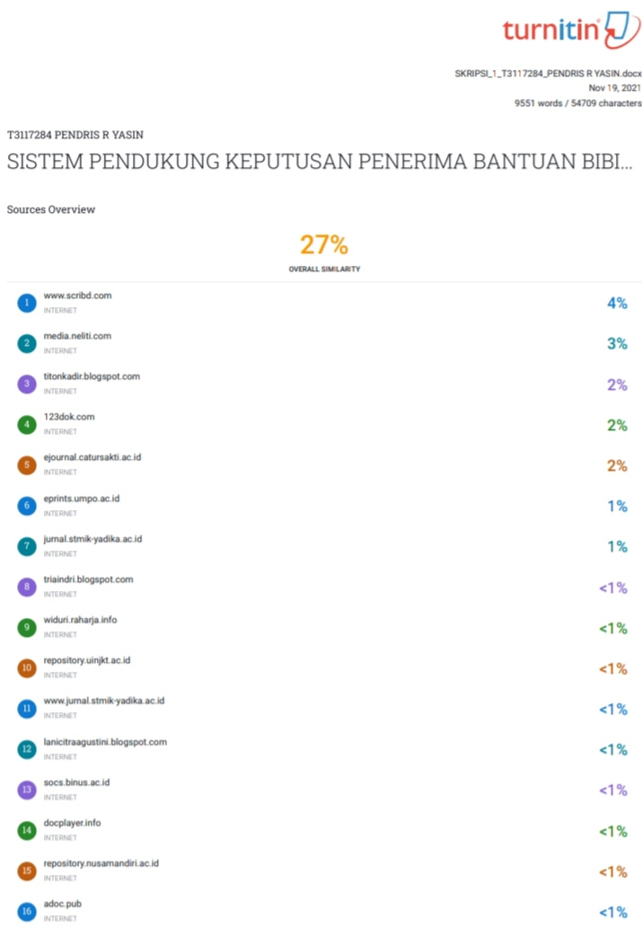

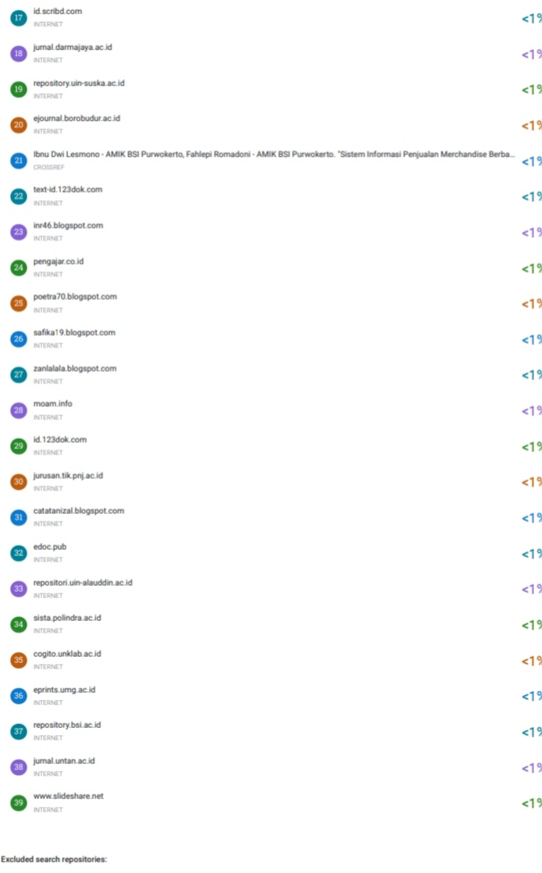


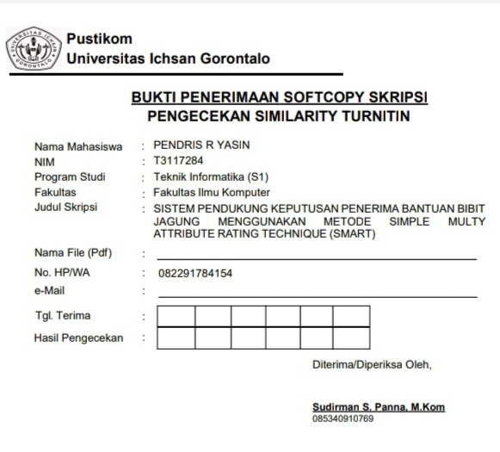

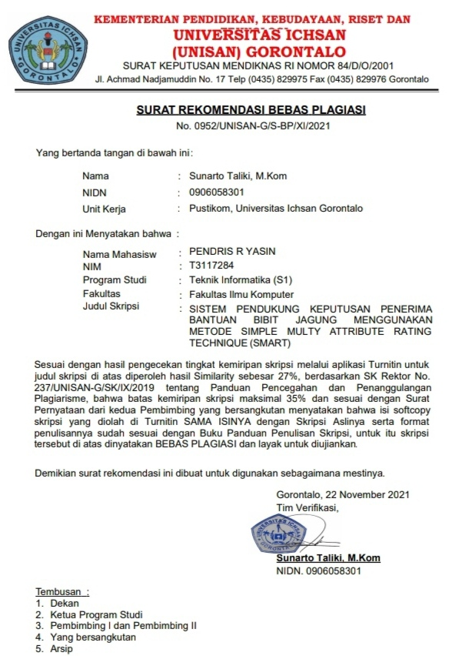


RIWAYAT HIDUP PENELITI

Nama : Pendris R. Yasin
Tempat/Tanggal Lahir : Marisa, 30 Agustus 1998
Jenis Kelamin : Laki - Laki
Agama : Islam
Alamat : Desa Manawa, Dusun Bunto, Kec. Patilanggio, Kab. Pohuwato, Provinsi Gorontalo
Email : pendrismobile@gmail.com
Orang Tua :
Ayah : Raman Yasin
Ibu : Yasni Suleman
Pendidikan Formal
- Tahun 2011, Menyelesaikan Pendidikan di SDN Inpres Manawa
- Tahun 2014, Menyelesaikan Pendidikan di SMP Negeri 1 Duhiadaa
- Tahun 2017, Menyelesaikan Pendidikan di SMK Negeri 1 Duhiadaa
- Tahun 2017, Mendafar dan diterima menjadi mahasiswa di Fakultas Ilmu Komputer Jurusan Teknik Informatika Universitas Ichsan Gorontalo

